KORAK Documentation

Abstract:

Korak is a 3GPP 5G NR standardization compliant radio link simulator.

This document describes the 5G algorithms implemented in Korak based on 3GPP 5G NR standards [1] [2] [3] [4]. Simulation results related to 5G NR algorithms can be found in [TBD, results folder?]

KORAK CONTRIBUTORS (last name ordered)

|  |  |
| --- | --- |
| Heikki Berg | 2007-2014 |
| Hesham Elgendi | 2017-/ |
| Juha Heiskala | 2004-2010 |
| Tero Ihalainen | 2011-/ |
| Pasi Kinunnen | 2015-/ |
| Toni Levanen | 2014-2019 |
| Mikko Maenpaa | 2014-2019 |
| Andrei Malkov | 2011-2012 |
| Honglei Miao | 2011-2012 |
| Jorge Morte | 2019-/ |
| Rafael Paiva | 2013 |
| Panayiotis Papadimitriou | 2011-2015 |
| Elena Peralta | 2017-/ |
| Ismael Peruga | 2019-/ |
| Kalle Raiskila | 2011-2014 |
| Kari Rikkinen | 2015-2019 |
| Karol Schober | 2014-2015 |
| Tobias Stitz | 2011-2012 |
| Oskari Tervo | 2018-/ |
| Juha Venalainen | 2020-/ |
| Tommi Zetterman | 2011-2014 |

# Document Change History

|  |  |  |
| --- | --- | --- |
| Date | Description of changes | Author |
| 15.04.2020 | - First version created  - Introduction section included (based on Korak legacy material) | Elena Peralta |
| 20.04.2020 | - Covariance Estimation description (based on LTE doc)  - 5G NR enhanced estimation method description included (IRC receiver) | Elena Peralta |
| 23.04.2020 | - Channel Estimation description - Wiener (based on LTE doc)  - Generic FD and TD Wiener parameterization in Korak included. New TOC description included in the FD. | Elena Peralta |
| 27.04.2020 | - Measurements: RSRP, RSSI, RSRQ, SNR (based on LTE doc)  - 5G NR reference signals parameterization description included: DMRS, CSI, SRS, PRACH, PTRS | Elena Peralta |
| 30.04.2020 | - RIM-RS detection algorithm description included  - DMRS detection algorithm description included | Elena Peralta |
| 18.05.2020 | - LDPC channel coding types included: Min-sum algorithm and sum-product algorithm | Elena Peralta |
| 19.05.2020 | - L2S mapping interface for NR added (based on *Korak L2S Mapping Interface for NR* slide set)  - Added fine tracking modelling section and description (based on LTE doc)  - Link adaptation description included based on *Link_Adaptation_Demystifying* slide set and first draft for NR downlink link adaptation | Elena Peralta |
| 22.05.2020 | - PRACH algorithm description included  - 5G NR TOE/TOC algorithm description included | Elena Peralta |
| 25.05.2020 | - PDSCH processing description included (based on LTE doc) and updated to include 5G NR description | Elena Peralta |
| 26.05.2020 | - Detector MMSE, detector MMSE interference suppression pior to TxD detection description included (based on LTE doc)  - Interference aware receivers, NAICS receivers description included (based on [5])  - MRC, LMMSE, IRC and SLIC receivers description included (based on LTE doc and [5]) | Elena Peralta |
| 27.05.2020 | - Channel models: extended link description included for interfering modelling and RIM modelling  - Fine tracking modelling included | Elena Peralta |
| 28.05.2020 | - Include XML schema description for the main sections (not specific algorithms) | Elena Peralta |
| 18.08.2020 | - Generic covariance estimation parameterization included, PUCCH generic parameterization included, updated XML schema description based on NR | Elena Peralta |
| 28.09.2020 | - OFDM signal generation for PRACH. Numerology definition and subframe generation illustrations for mu=0 (15kHz). | Elena Peralta |
|  |  |  |
|  |  |  |
| To do | - VRB to PRB mapping description  - SRS | Jorge Morte? |
| To do | - PDCCH parameterization description  - PDCCH interleaver algorithm?  - HST scenario modelling  - Interference measurement methods (NZP-CSI, IM) | Hesham Elgendi? |
| To do | - PUCCH parameterization description  - Antenna array and panel antenna array modelling  - TRXU virtualization  - TRP and UE beamforming  - SNR loop  - Intra slot frequency hopping | Pasi Kinunnen? |
| To do | - Waveforms  - Power amplifier (PA) models  - Channel coding | Toni Levanen?  Ismael Peruga? |
| To do | - Frequency offset estimation (AFC)  - PT-RS based CPE compensation  - Tx Error Vector Magnitude (EVM)  - Phase noise modelling (estimation and compensation)  - URLLC (fixed harq?) | Ismael Peruga (PN)? |

# Abbreviations

|  |  |
| --- | --- |
| 3GPP | 3rd Generation Partnership Project |
| AWGN | Additive white Gaussian noise |
| BER | Bit Error Rate |
| BLER | Block Error Rate |
| BS (gNB) | Base Station |
| CE | Channel Estimation |
| CIR | Channel Input Response |
| CP | Cyclic Prefix |
| CRC | Cyclic Redundancy Check |
| CSIRS | Channel state information Reference Signal |
| DMRS | Demodulation Reference Signal |
| FEC | Forward Error Correction |
| FFT | Fast Fourier Transform |
| HARQ | Hybrid Automatic Repeat Request |
| ISI | Intersymbol Interference |
| LSC | Link Simulator Core |
| LTE | Long Term Evolution |
| MCS | Modulation and Coding Scheme |
| MIMO | Multiple-Input and Multiple-Output antenna technology |
| MMSE | Minimum mean square error |
| MRC | Maximum Ratio Combining |
| OFDM | Orthogonal frequency domain multiplexing |
| PBCH | Physical broadcast channel |
| PDCCH | Physical downlink control channel |
| PDSCH | Physical downlink shared channel |
| PRACH | Physical random access channel |
| PRB | Physical Resource Block |
| PRS | Positioning Reference Signal |
| PSS | Primary synchronization signal |
| PTRS | Phase Noise Tracking Reference Signal |
| PUCCH | Physical uplink control channel |
| PUSCH | Physical uplink shared channel |
| QAM | Quadrature Amplitude Modulation |
| QPSK | Quadrature Phase Shift Keying |
| RIM-RS | Remote Interference Management Reference Signal |
| RB | Resource Block |
| RS | Reference Signal |
| SNR | Signal to noise ratio |
| SINR | Signal to interference noise ratio |
| SRS | Sounding Reference Signal |
| TOC | Time offset compensation |
| TOE | Time offset estimation |
| UE | User Equipment |
| UL | Uplink |
|  |  |
|  | Number of DL resource blocks |
|  | Cell ID |

Table of Contents

Document Change History 2

Abbreviations 3

1. Introduction 8

1.1 Operating the simulator 8

1.1.1 The parameter file 8

1.1.2 XML schema 10

1.2 The simulation loop 15

2 Downlink 17

2.1 Physical channels 17

2.1.1 PDSCH 17

2.1.2 PDCCH 21

2.1.3 PBCH 21

2.2 Physical reference signals 27

2.2.1 DMRS for PDSCH 27

2.2.2 PTRS for PDSCH 30

2.2.3 DMRS for PDCCH 30

2.2.4 DMRS for PBCH 30

2.2.5 CSI 31

2.2.6 RIM-RS 32

2.2.7 PRS 34

3 Uplink 35

3.1 Physical channels 35

3.1.1 PUSCH 35

3.1.2 PUCCH 35

3.1.3 PRACH 36

3.2 Physical reference signals 39

3.2.1 DMRS for PUSCH 39

3.2.2 PTRS for PUSCH 39

3.2.3 DMRS for PUCCH 39

3.2.4 SRS 40

4 Synchronization and tracking 41

4.1 PSS and SSS generation and tracking 41

4.2 Efficient SSS Detection 41

4.2.1 Coherent SSS Detector 41

5 Covariance Estimation from Common Reference Symbols or Demodulation Reference Symbols (CSI/DMRS) 42

5.1.1 CRS Based Channel Estimation at High Level 42

5.1.2 Raw Channel and Covariance Estimation 43

6 Channel Estimation from Common Reference Symbols or Demodulation Reference Symbols (CSI/DMRS) 51

6.1.1 The Wiener Estimator 52

6.1.2 Ideal Estimator 63

7 Measurements 64

7.1.1 RSRP calculation 64

7.1.2 RSSI calculation 66

7.1.3 RSRQ calculation 66

7.1.4 SNR calculation 66

7.1.5 Interference measurements methods 66

8 Channel coding 67

8.1 LDPC 67

8.1.1 Min-sum algorithm 67

8.1.2 Sum-product algorithm 68

8.2 Turbo 69

8.3 Polar Codes 69

9 Waveforms 70

9.1 Processing 70

9.1.1 FD and TD transform block 70

9.1.2 Filtering block 70

9.1.3 PAPR reduction block 70

9.1.4 Preprocessing block 70

9.1.5 Spectral Shaping block 70

9.1.6 Time Domain processing block 70

9.1.7 Windowing block 70

9.2 NR candidates waveforms 70

9.2.1 CP-OFDM 70

9.2.2 DFT-s-OFDM 70

9.2.3 FCFB-F-OFDM 70

9.2.4 UFMC 70

9.2.5 WinSic-F-OFDM 70

9.2.6 WOLA 70

9.2.7 ZT-DFT-s-OFDM 70

10 Channel models 71

10.1 3GPP Tapped Delay Line Models 71

10.2 3GPP Clustered Delay Line Models 71

10.3 Matlab TDL model 72

10.4 Single Link 72

10.5 Extended link (System Simulator w/ LL Simulation) 72

10.5.1 Interfering modelling 73

10.5.2 RIM modelling 74

11 Receiver 76

11.1 Receiver front end 76

11.1.1 RF impairments 77

11.1.2 Time offset estimation/compensation 77

11.1.3 Frequency offset estimation/compensation 78

11.1.4 Cyclic Prefix Removal 78

11.1.5 Frequency hopping 78

11.1.6 VRB to PRB mapping 79

11.1.7 Fast Fourier Transform 79

11.2 Detector MMSE 79

11.2.1 Implementation aspects 80

11.3 Detector MMSE interference suppression prior to TxD detection 80

11.3.1 MMSE across Rx Antennas (sub-optimum receiver) 80

11.3.2 Full MMSE solution for 2x2 SFBC 82

11.4 Maximal Ratio Combiner (MRC) and Transmit Diversity Detection 82

11.5 Linear Minimum Mean Square Error (LMMSE) 83

11.6 Interference aware receivers 84

11.6.1 NAICS receivers 84

11.7 Transmit diversity detector (Space-Frequency Block Code (SFBC)) 85

11.7.1 2x2 SFBC Detector 85

11.8 Interference Rejection Combining (IRC) Receiver 85

11.8.1 Background 85

11.8.2 Implementation 85

11.9 Symbol Level Interference Cancellation (SLIC) 86

11.10 Successive Interference Cancellation (SIC) Receiver 86

12 Antenna array and panel antenna array modelling 87

12.1 TRXU virtualization 87

12.2 TRP and UE beamforming 87

13 Link adaptation (LA), Outer Loop Link Adaptation (OLLA) 88

13.1 Link abstraction algorithm 88

13.2 NR downlink link adaptation 91

13.2.1 Channel Quality Indicator Definition and Calculation 91

13.2.2 Outer Loop Link Adaptation (OLLA) 91

13.2.3 Generic parameterization 92

14 Link to system (L2S) Mapping Interface 94

14.1 L2S mapping for SLIC Receiver (check) 94

14.1.1 Mutual information effective SINR mapping 94

14.2 Modeling approach in NR 98

14.2.1 Calculation of BLER 99

14.2.2 Interpolation process between the reference curves 100

14.2.3 Calculation of BLER in case of code block segmentation 100

15 Fine Tracking Modelling 102

15.1 Time Offset Modelling 102

15.1.1 Model A 102

15.1.2 Model B 102

15.2 Frequency Offset Modelling 102

15.2.1 Model B 102

16 Others 103

16.1 Tx Error Vector Magnitude (EVM) 103

16.2 High Speed Train (HST) scenario modelling 103

16.3 Power amplifier (PA) models 103

17 References 104

# Introduction

Please refer to the following page in Confluence for detailed information:

https://confluence.ext.net.nokia.com/display/korak/Getting+started

## Operating the simulator

The link simulator Korak can be run within the Matlab environment or alternatively it can be compiled to a standalone executable. A simulation run requires always a parameter file which defines the basis for the simulation in XML-form. The results are also written to an XML-file by the simulator and the gathered data can be further analysed using Matlab functions and tools.

### The parameter file

A simulation run is defined by a parameter file that has information on the simulation length, transmitter, channel coding and modulation etc. Some parameters are still hardcoded in the m-files of the simulator, but they should be relocated to the parameter file if a certain value needs to be changed frequently. Otherwise, it is necessary to recompile the simulator for each of the parameter value, which may become time-consuming. The parameter file is a structured document and it is divided into logical sections that model the simulated system. The grouping of similar parameters makes the file more human-legible and easier to modify. The main sections are described here briefly.

#### Section: simulation

Please refer to the following page in Confluence for detailed information:

https://confluence.ext.net.nokia.com/display/korak/Parameter+file+definition

#### Section: network-sites

Please refer to the following page in Confluence for detailed information:

https://confluence.ext.net.nokia.com/display/korak/Parameter+file+definition

#### Section: network-user-equipment

Please refer to the following page in Confluence for detailed information:

https://confluence.ext.net.nokia.com/display/korak/Parameter+file+definition

### XML schema

|  |  |
| --- | --- |
| Author | Elena Peralta, Jorge Morte |

Please refer to the following page in Confluence for detailed information:

https://confluence.ext.net.nokia.com/display/korak/Schema+definition+(XSD)

## The simulation loop

|  |  |
| --- | --- |
| Author | Panayiotis Papadimitrou |

Simulation starts with the initialization of parameter structures, the used set of functions and objects that are operated through the Lsc-library. The simulation loop itself consists of three loops. The utmost loop goes through every SNR-point specified in the parameters. The middle loop handles the fast fading drops, i.e. all the independent channel realizations. The inmost loop handles the sub-frames that belong to a fast fading drop. Most of the action takes place in the inmost loop, where data is generated and sent over the channel, the transmission is received, and performance statistics are calculated. After the SNR-points have been processed, the final link statistics are printed to an XML result file. This simulation process is discussed in more detail in the rest of this section and it is visualized in the Figure 1‑5 and in more detail in Figure 1‑6.

The sub-frames that have correlated channel realizations with the difference calculated from the speed of the mobile are said to belong to the same fast fading drop. In the beginning of a fast fading drop, a new channel realization is forced, and after that, the channel depending on the mobile speed for consecutive sub-frames is updated. The number of fast fading drops per SNR-point has an effect on the accuracy of the results. With more drops within one SNR-point, data will be transmitted through more diverse channels and the averaged performance results settle to a smoother curve. Sub-frames within a fast fading drop have channel realizations that are dependent of each other. This simulation characteristic can be used to evaluate features that process consecutive subframes, e.g. channel estimation over multiple sub-frames.

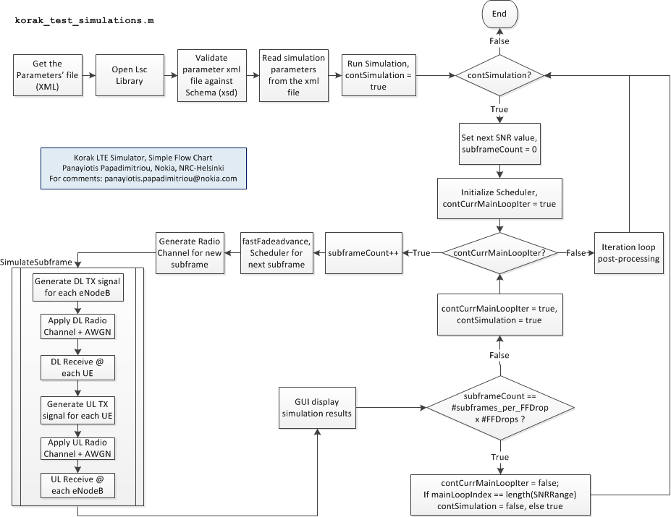

Figure 1‑5 Korak flow chart

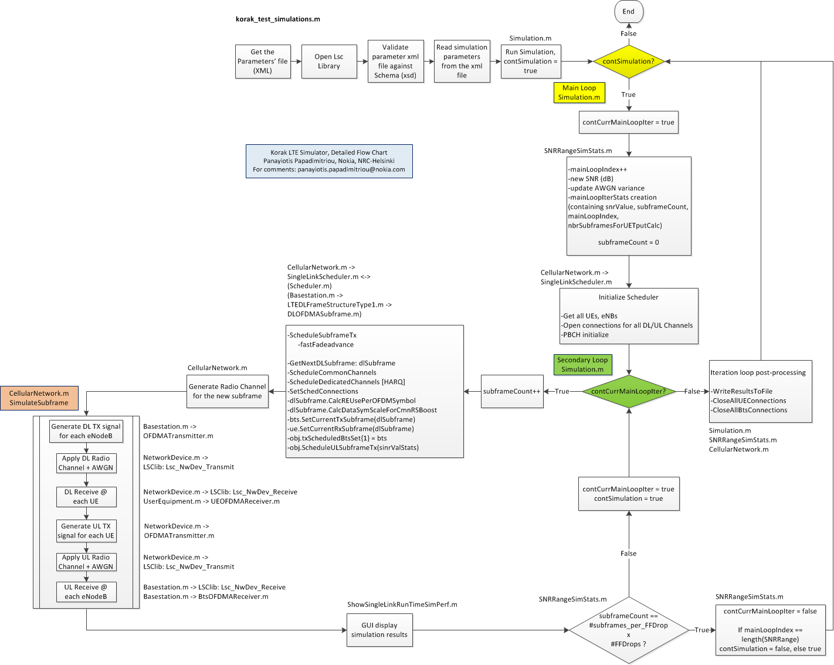

Figure 1‑6 Korak detailed flow chart

The loop index named fastfadeDropIdx runs from 1 to the number of fast fading drops per SNR-point. It is the index of the middle loop of the three loops creating the simulation loop. For every fast fading drop a totally new channel realization is generated and the HARQ processes are reset (if specified in the parameters).

The inmost loop going through the sub-frames within a drop has a loop index named as subFrameIdx. Within that loop, the channel is only updated (not completely randomized) taking into account the mobile speed and the 1 ms time difference between sub-frames (for SCS 15kHz). In this loop, one sub-frame is constructed from symbols that are placed in the time-frequency resource grid. This sub-frame travels through a channel and is decoded. Based on the CRC checksum, the receiver makes the decision, whether or not the codeword was received correctly. Depending on the used setting, the receiver may request a retransmission through an HARQ process and combine the original received data and the retransmissions. At any rate, the success of a transmission and the amount of received bits are always stored for each HARQ process along with general link related information. This stored data is used to calculate the statistical values of the link performance for each of the SNR-points.

# Downlink

## Physical channels

### PDSCH

|  |  |
| --- | --- |
| Author | Panayiotis Papadimitrou, Tero Ihalainen, Pasi Kinunnen, Toni Levanen, Mikko Manepaa, Elena Peralta, Hesham Elgendi |
| Related functions | NRPdschChannelCode.m, NRPdschCodeword.m, GenericWaveform.m |

#### General

PDSCH is the main physical downlink channel. It is mainly used for user data, but it also carries system information (system information blocks, SIBs, not carried in the PBCH), and also paging information as there isn’t explicit paging physical channel. The PDSCH data are transmitted via the so called transport blocks (from the corresponding transport channels), which correspond to the MAC PDU, in a Transmission Time Interval (TTI) of 1ms (1 subframe/slot), 0.5ms (1 slot), 0.25ms (1 slot), 0.125ms (1 slot) for 15kHz, 30kHz, 60kHz, 120kHz subcarrier spacing, respectively. 240kHz subcarrier spacing is supported for PSS, SSS and PBCH channels while 1.25kHz and 5kHz for PRACH channel.

##### Transport channel processing

The PDSCH carries not only user data, but also system and paging information. In protocol terms, the PDSCH carries the transport blocks of the transport channels DL-SCH and PCH. The processing of the transport blocks of the transport channels DL-SCH and PCH (the result is the codeword(s)) is given in Figure 2‑1 and has as following [38212, par. 5.3.2]:

* Add CRC to the transport blocks
* Code block segmentation and code block CRC attachment
* Channel coding
* Rate matching (and Interleaving)
* Code block concatenation

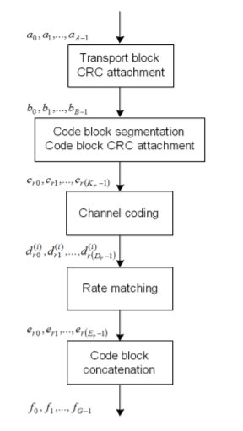

Figure 2‑1 Transport channels DL-SCH and PCH processing

###### CRC

The CRC code provides error detection (which is not error free), and is used to determine whether the corresponding packet was successfully received and decoded.

In LTE, the parity bits (CRC bits) are computed and attached to the transport block according to section 5.1.1 of TS 36212 setting L to 24 bits and using the generator polynomial gCRC24A(D). In NR, the parity bits (CRC bits) are computed and attached to the transport block according to TS 38.212 v1.0.1 (2017-09): 5.1. CRC calculation setting L to 24, 16, 9, 6 bits and using the generator polynomial gCRC24A(D), gCRC24B(D), gCRC24C(D), gCRC16(D), gCRC11(D), gCRC6(D).

###### Code block segmentation

The code block segmentation is needed to divide into smaller segments a large transport block, probably (our assumption) due to UE memory/processing constraints reasons. Code block segmentation and code block CRC attachment are performed according to section 5.1.2 of TS 36212 or 5.2.2 of TS 38212 (LDPC base graph selection in section 6.2.2 of TS 38212). Note that the CRC coding of the code block segments is not to be confused with the CRC coding of the transport block of the previous section.

###### Channel coding

In LTE, the DL-SCH and the PCH (that will be transmitted through the PDSCH) are Turbo coded with coding rate of 1/3. Note that each code block resulted from the above segmentation is individually turbo encoded, according to section 5.1.3.2 of TS 36212. In NR, the DL-SCH and the PCH are coded using LDPC codec with varying value of coding rate (see section 8.1 of this document).

###### Rate matching

The coded blocks are delivered to the rate matching block. Each coded block is individually rate matched according to section 5.1.4.1 of TS 36212 or 5.4.2 of TS 38212. Note that the rate matching block performs also interleaving of the coded bits.

###### Code block concatenation (Codeword generation)

In LTE, the coded blocks, after being rate-matched, they are proceeding to code block concatenation, which is performed according to section 5.1 of TS 36212. The sequence of the coded bits corresponding to one transport block after code block concatenation is referred to as one **codeword** in section 6.3.1. In case of multiple transport blocks per TTI, the transport block to **codeword mapping** is specified according to section 5.3.3.1.5, 5.3.3.1.5A or 5.3.3.1.5B, depending on the DCI Format.

In NR, the code block concatenation is performed according to section 5.1.3 of TS 38212. There are three different MCS tables defined, table 1 and 3 support up to 64QAM modulation, and table 2 supports up to 256QAM modulation. Table 3 is specifically designed for URLLC. NR supports one codeword for 1 to 4 layer transmission and 2 codewords for 5 to 8 layer transmission.

##### Processing

The baseband signal of the PDSCH channel, after the transport channel processing of the previous section, is created in the following steps, as shown in Figure 2‑2:

* **scrambling** of the bits in each of the codewords to be transmitted
* **modulation** of scrambled bits to generate complex-valued modulation symbols
* **mapping** of the complex-valued modulation symbols onto one or several **transmission layers**
* **precoding** of the complex-valued modulation symbols on each layer for transmission on the antenna ports
* **mapping** of complex-valued modulation symbols for each antenna port to **resource elements**
* **generation** of complex-valued time-domain **OFDM signal** for each antenna port

Note that this is the general structure for the downlink physical channels.

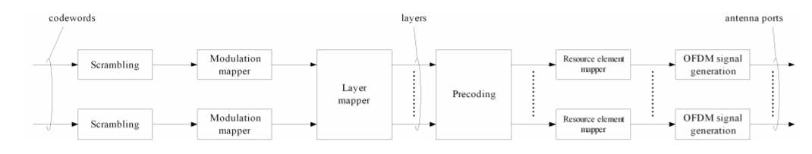

Figure 2‑2 PDSCH processing

###### Scrambling

For each codeword, the block of bits shall be scrambled prior to modulation, resulting in a block of scrambled bits, where the scrambling sequence is given in LTE [36211, par. 6.3.1] and in NR [38211, par. 7.3.1.1], and is initialized at the start of each subframe with the following initial value that depends on the transport channel type to be transmitted through PDSCH for LTE:



where nRNTI is the RNTI associated with the PDSCH transmission as described in clause 7.1 3GPP TS 36.213, and ns/2 ∈ [0, 9] is the subframe number (or equivalently ns is the slot number) within the radio frame. q ∈ {0, 1} is the codeword number (when there is only one codeword q = 0). Note that up to two codewords can be transmitted in one subframe.

and for NR:

where nRNTI is the RNTI associated with the PDSCH transmission as described in clause 5.1 of [6, TS 38.214].

###### Modulation

The signal after scrambling proceeds to modulation to yield the (complex-valued) modulation symbols. In LTE, the modulation schemes supported are QPSK, 16QAM and 64QAM [36211, par. 6.3.2]. The modulation is described in detail in [36211, par. 7.1]. In NR, the modulation schemes supported are QPSK, 16QAM, 64QAM, 256QAM [38211, par. 7.3.1.2]. The modulation is described in detail in [38211, par. 5.1].

###### Layer Mapping

To do

###### Precoding

To do

###### Antenna port mapping

To do

###### Mapping from virtual to physical resource blocks

To do

###### OFDM signal generation

OFDM signal generation for all channels except PRACH and RIM-RS is implemented according to TS 38211, section 5.3.1.

OFDM signal generation for RIM-RS 2OS

There are two NR RIM-RS solutions with one (1OS) and two (2OS) OFDM symbols, respectively. Further details can be found in section 10.5.2. The 2OS RIM-RS design, similar to the LTE RIM-RS, builds on two copies of the selected full-band sequence while the CP length is doubled to align the number of transmitted samples with two CP-OFDM symbols. The approach is similar as the one followed for PRACH channel.

The so-called PRACH-like OFDM baseband signal generation should be allocated in at least 2 adjacent OFDM symbols. Therefore, the total number of copies or repetitions () of the selected full-band sequence is in the range of [2,], where is the subframe length (e.g 14 OFDM symbols). To generate this signal there is an attribute *prach-like-OFDM* in the XML. For the case *prach-like-OFDM* equals "yes" the processing is as follows:

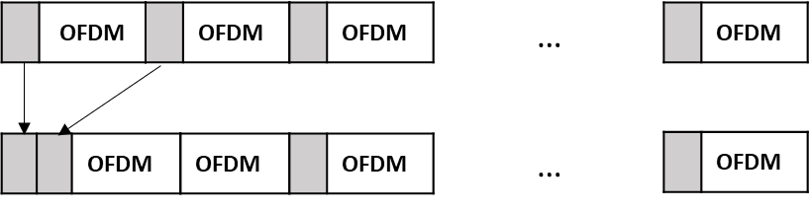

Figure 2‑3 OFDM signal generation for RIM-RS 2OS

#### Channel estimation

The raw channel estimation is described in section 5.1.2.1 and the detector MMSE in section 11.2.

#### Time Offset Estimation

Time offset estimation methodologies are described in section 2.2.1.4 for DMRS.

*(Generic implementation under development)*

#### Time Offset Compensation

Time offset compensation (TOC) is performed once per subframe shifting the received signal or before performing the channel estimation in the wiener filter (practical CE) for all received data symbols based on two possible approaches: ideal TO (assumed known at the receiver) or DMRS TOE. Therefore, the timing offset correction is based on the timing offset estimate from the previous subframe and the Rx signal () is shifted as:

or the autocorrelation and cross-correlation matrixes as defined in section 6.1.1.1.3 for the wiener interpolation of the channel in Frequency direction are shifted as:

where should be calibrated for specific scenario. By default, equals to delay spread of the channel is assumed.

#### Frequency Offset Estimation

To do

#### Frequency Offset Compensation

To do

#### Phase Noise Estimation

To do

#### Phase Noise Compensation

To do

### PDCCH

|  |  |
| --- | --- |
| Author | Hesham Elgendi |
| Related functions | NR_PDCCH |
|  |  |

#### General

To do

### PBCH

|  |  |
| --- | --- |
| Author | Panayiotis Papadimitriou, Mikko Maenpaa |
| Related functions | Folder nr_pbch |
|  |  |

#### General (check LTE and NR implementation and update diagrams)

PBCH is a channel that carriers basic system information to enable the correct decoding of the control and data channels, comprising:

- Master Information Block (MIB), which is carried on PBCH and contains: downlink system BW, PHICH structure, and the 8 most significant bits of the system Frame Number.

- Other System Information Blocks (SIBs) which are multiplexed in the PDSCH

In Figure 2‑4 the PBCH structure is depicted. MIB is 24 bits long, out of which only 14 are the information bits, which have the information shown in Table 1-1:

Table 1-1 MASTER INFORMATION BLOCK, 14 INFORMATION BITS

|  |  |
| --- | --- |
| **Bits** | **Description** |
| 1:3 | DL Bandwidth |
| 4:6 | PHICH configuration |
| 7:14 | 8 MSB of the System Frame Number (SFN) |

The correspondence of the 3 MSB of the MIB to the downlink bandwidth is given in Table 1-2:

Table 1-2 MASTER INFORMATION BLOCK, DL BANDWIDTH BITS

|  |  |
| --- | --- |
| **#PRBs** | **DL Bandwidth Bits** |
| 6 | [0 0 0] |
| 15 | [0 0 1] |
| 25 | [0 1 0] |
| 50 | [0 1 1] |
| 75 | [1 0 0] |
| 100 | [1 0 1] |

As shown in the PBCH structure figure, a 16-bit CRC is attached to the 24 bits of the MIB. This CRC is masked (scrambled) with the mask given in Table 1-3 which depends on the number of eNodeB transmit antennas 1, 2, or 4

Table 1-3 CRC MASK FOR PBCH

|  |  |
| --- | --- |
| **Number of transmit antenna ports at eNB** | **PBCH CRC mask** |
| 1 | <0,0,0,0,0,0,0,0,0,0,0,0,0,0,0,0> |
| 2 | <1,1,1,1,1,1,1,1,1,1,1,1,1,1,1,1> |
| 4 | <0,1,0,1,0,1,0,1,0,1,0,1,0,1,0,1> |
| 50 | [0 1 1] |
| 75 | [1 0 0] |
| 100 | [1 0 1] |

Figure 2‑4 PBCH Structure [7]

The 40 (24+16) PBCH source bits are convolutionally encoded and rate-matched to yield 1920 coded bits for normal cyclic prefix (CP), which are also scrambled with a cell-specific sequence prior to modulation, where the scrambling sequence is initialized with in each radio frame fulfilling mod4 = 0. This scrambling is needed to make sure the receiver is locked to the desired cell.

After channel encoding, PBCH is transmitted in 4 segments (to get time diversity gain), of 480 bits each, in each radio frame at subframe #0 with 40ms periodicity. PBCH is QPSK modulated and the resource allocation of PBCH is fixed and independent of system BW or number of tranmsit antennnas (always it is transmitted in the central 6 PRBs).

#### PBCH Detection

The PBCH detection shall be divided into two modes:

- Initial PBCH acquisition (after initial PSS/SSS acquisition)

- PBCH tracking/decoding (during regular operation)

As mentioned, the PBCH detection will yield directly: a. downlink system BW, b. PHICH structure, and c. the 8 most significant bits of the System Frame Number (SFN). Indirectly the PBCH detection shall yield the number of eNB transmit antenna ports, as well the 2 least significant bits of the SFN.

##### Initial PBCH acquisition

Initial PBCH acquisition mode shall occur after PSS/SSS successful initial acquisition, and the logic diagram is shown in Figure 2‑5. UE shall focus on subframe #0 (see Fig. 1.4) while receiving PBCH. The use of timers is needed to make the receiver stable, and correct possible mistakes (false-alarms) of the PSS/SSS detection. The initial value of the timer is to be adjusted in the receiver’s fine tuning.

In Figure 2‑5, we gave the overall initial PBCH detection diagram, without getting into the details of the “PBCH Receiver” which is to be done next.

###### PBCH Receiver

In the initial detection, the UE doesn’t know the timing of the 40ms transmission interval, nor the number of eNodeB transmit antennas, therefore it should perform “blind” decodings of the PBCH using each of the 4 possible phases of the scrambling code (cell-specific sequence) mentioned earlier and checking the CRC after each decoding. Also, since the number of transmit antennas is not known also, one may try to reduce the complexity of so many blind decodings, by measuring the various Tx-Rx channels’ powers and give a hint for the most probable Tx antenna ports used by the eNB.

The PBCH receiver mentioned in Figure 2‑5, is given in detail in Figure 2‑6. Here after getting the PBCH resource elements corresponding to a single subframe, of size 240, we proceed generating the PBCH cell-specific scrambling sequence of size 4x480, only if the NIDcell changed from the previous function call.

Then we start cycling (in a for loop) over the possible number of transmit antennas (1, 2 or 4), with the most probable number first, e.g. 2 (this can be offline, or could be given as a hint from the channel estimation module).

Depending on the currently set number of Tx Antennas we detect accordingly the signal, MRC or TxD detector [see MRC definition in section 11.4], and then proceeding to update the soft bits buffer (each buffer for each corresponding number of transmit antennas). The length of the buffer over 480 gives the number of frames, say Frames, to be used for the PBCH detection.

We proceed, then, into a loop by attempting to decode the soft bits buffer in decreasing frames order. i.e. first try to decode the full buffer, if this fails, try to decode the reduced by one frame buffer, and so on. It was implemented this way for ease of implementation. Any other adhoc method can of course be followed. Of course the easiest solution would be to buffer four consecutive subframes #0 and try decoding, but this would yield to decoding time of 40-70ms which may not be acceptable. The “PBCH decode” module will be explained later, and is yielding the detected MIB, the SFN, and the CRC result.

The “PBCH decode” module will be explained later, and is yielding the detected MIB, the SFN, and the CRC result.

After that loop ends we ’re doing some housekeeping, i.e. keeping buffer up to 40ms long, and depending on the CRC result, cycling over the next number of transmit antennas candidate, or exiting the module after reducing the PBCH Timer.

###### PBCH Decode module

The PBCH Decode module, is receiving the soft bits buffer, along with the Frames number and the number of Tx Antennas under investigation, and proceeds as depicted in Figure 2‑7, by multiplying the soft bits buffer with all 4 possible phase of the scrambling sequence and attempting decoding.

##### PBCH tracking/decoding

After initial PBCH acquisition, the UE knows the SFN and the eNB’s Tx antennas configuration, therefore there is no need for PBCH blind decodings (at first decoding attempt, if this fails there should be). This is achieved by the update of the arrays holding the order of Tx Antennas’ search (NbrTxAntennas2Check) and the order of the scrambling sequence phases’ search (cidx). As subframes #0 arrive, the UE can start decoding (with soft combining within the 40ms PBCH periodicity, as needed). Figure 2‑8 shows the PBCH tracking logic during normal reception.

Figure 2‑5 Initial PBCH acquisition/detection, [7]

Figure 2‑6 PBCH receiver [7]

Figure 2‑7 PBCH Decode module [7]

Figure 2‑8 PBCH Tracking [7]

#### Frequency Offset Estimation

To do

## Physical reference signals

### DMRS for PDSCH

#### General

|  |  |
| --- | --- |
| Author | Tero Ihalainen, Toni Levanen, Elena Peralta |
| Related functions | cmwPDSCH_DMRS.m, NR_PDSCH_DMRS_REL15.m |

There are two implementations available for this signal:

1. Implementation A: cmwPDSCH_DMRS.m class. Default option. Prior to NR Release 15.
2. Implementation B: NR_PDSCH_DMRS_REL15.m class. Implemented according to TS 38.211 Release 15.

##### Implementation A

|  |  |  |  |
| --- | --- | --- | --- |
| **Parameter** | **Description** | **Value** | **Default value** |
| resource-blocks | Resource block bundle size | string | i.e X:step:Z for step = 1 |
| power-boost-dB | inverse of DMRS EPRE value  Value in dB | integer | 0 | 3 | 6 |
| dmrs-port  idx | Dmrs port index | integer | [1 2 3 …6] |
| dmrs-port  RE-allocation-within-PRB-bit-map | Mapping to physical resources. | string | - |
| symbol  idx | OFDM symbols index | integer | [1 2 3 … slotLength] |
| symbol  PRB-allocation-within-symbol | PRB allocation within a slot.  Note: range should be within resource-blocks range | string | i.e X:step:Z for step = 1 |
| reserve-symbol-for-DRMS | indicator for reserving empty REs in DMRS symbol (not allocated for PDSCH) | string | yes | no |
| inter-hop-set | PRB resolution for each suframe, any integer is allowed, repeats pattern for subframe. | array |  |
| intra-hop-set | PRB resolution within subframe, first row similar as inter-hop-set, second row defines symbol index (starting from 0) for each frequency hop | array |  |

##### Implementation B

|  |  |  |  |
| --- | --- | --- | --- |
| **Parameter** | **Description** | **Value** | **Default value** |
| resource-blocks | Resource block bundle size | string | i.e X:step:Z for step = 1 |
| version | release version | string | REL15 |
| configuration-type | configuration type 1 or 2 | integer | 1 | 2 |
| mapping-type | mapping type A or B | string | A | B |
| type-A-starting-index | index to first DMRS symbol, OFDM symbol indexing starts from 0 | string |  |
| active-antenna-ports | active antenna ports defined | integer  (array) | type 1: 1000 |… | 1007  type 2: 1000 |… | 10011 |
| N_ID | used for pseudo-random sequence generator initialization | integer | 49 |
| n_SCID | used for pseudo-random sequence generator initialization | integer | 0 |
| slot-length | slot length | integer | 14 |
| number-of-additional-DMRS-positions | number of additional DMRS symbols |  | type A: 0 | 1 | 2 | 3  type B: 0 | 1 |
| number-of-CDM-groups-without-data | indirect indicator for DMRS power boost, see TS 38.212 V15.5.0 Section 7.3.1.1.2 for more information |  | type 1: 1 | 2  type 2: 1 | 2 | 3 |
| LTE-CRS-ToMatchAround | indicator for using value L_1=12 related to higher-layer parameter lte-CRS-ToMatchAround | string | yes | no |
| reserve-symbol-for-DRMS | indicator for reserving empty REs in DMRS symbol (not allocated for PDSCH) | string | yes | no |
| distributed-PRBs | indicator to allow distributed PRB allocations. In this case resource-blocks can be e.g x:step:y for y>1 | string | yes | no |
| inter-hop-set | PRB resolution for each suframe, any integer is allowed, repeats pattern for subframe. | array |  |
| intra-hop-set | PRB resolution within subframe, first row similar as inter-hop-set, second row defines symbol index (starting from 0) for each frequency hop | array |  |

#### Sequence generation

To do (korak differentiated by releases)

#### Detection algorithm

|  |  |
| --- | --- |
| Author | Mikko Maenpaa, Elena Peralta |
| Related functions | CustomSequenceDetector.m |

NR specifies a configured-grant (CG) access mode for the uplink, also known as grant-free mode, that allows UEs to transmit data without time-consuming scheduling requests (UE to the base station) and grants (base station to the UE). Since the usage of the preconfigured CG resources is determined by the data arrival process at the UE, the base station is not aware of the CG resources that are used by an UE. Therefore, CG transmissions introduce the necessity of user transmission detection at the gNB [8]. In this case, the detection performance is analysed using DMRS signals in grant-free configurations. The main processing approach for the DMRS detection is as follows (complete formulas):

- Step 1: Convert received signal to frequency domain (CP removal, FFT)

- Step 2: Get received DMRS sequence in FD

- Step 3: For every Rx antenna port, perform correlation:

- Step 4: Convert correlation result to time domain:

- Step 5: combine correlation result in time domain from each Rx port using normalized mean based on maximum peak values.

- Step 6: Threshold determination is based on PAPR. In this case, we use the information of the distribution of the noise correlation peaks to obtain the proper detection threshold. The distribution is collected from the correlator outputs with inputs containing only noise, obtained when the DM-RS is not transmitted, to enhance the detection performance and to update the detection threshold based on a given false alarm target as follows:

1: False alarm probability target

2:

3: = sort(**w**)

4: Detection threshold

5: **for** n = 1 to **do**

6:

7:

8: **end for**

9:

#### Time Offset Estimation

|  |  |
| --- | --- |
| Author | Elena Peralta |
| Related functions | NR_PDSCH_DMRS_REL15 |

The main processing approach for the DMRS TOE is as follows (complete formulas):

- Step 1: Combine information over DMRS symbols (coherent accumulation)

where *z* is the raw channel estimate, which contains AP wise channel estimates over all REs and OFDM symbol pairs.

- Step 2: Normalized mean based on maximum peak values for each antenna

- Step 3: Look for maximum peak and estimate offset.

- Step 4: Give estimated offset as input to wiener CE per subframe and fast fading drop:

#### Frequency Offset Estimation

|  |  |
| --- | --- |
| Author | Toni Levanen, Mikko Maenpaa |
| Related functions | NR_PDSCH_DMRS_AFC |

To do

### PTRS for PDSCH

#### General

|  |  |
| --- | --- |
| Author | Tero Ihalainen |
| Related functions | cmwPDSCH_PTRS.m |

|  |  |  |  |
| --- | --- | --- | --- |
| **Parameter** | **Description** | **Value** | **Default value** |
| resource-blocks | Resource block bundle size | string | i.e X:step:Z for step = 1 |
| power-boost-dB | inverse of DMRS EPRE value  Value in dB | integer | 0 | 3 | 6 |
| dmrs-port  idx | Dmrs port index | integer | [1 2 3 …6] |
| dmrs-port  RE-allocation-within-PRB-bit-map | Mapping to physical resources. | string | - |
| symbol  idx | OFDM symbols index | integer | [1 2 3 … slotLength] |
| symbol  PRB-allocation-within-symbol | PRB allocation within a slot.  Note: range should be within resource-blocks range | string | i.e X:step:Z for step = 1 |
| reserve-symbol-for-DRMS | indicator for reserving empty REs in DMRS symbol (not allocated for PDSCH) | string | yes | no |
| inter-hop-set | PRB resolution for each suframe, any integer is allowed, repeats pattern for subframe. | array |  |
| intra-hop-set | PRB resolution within subframe, first row similar as inter-hop-set, second row defines symbol index (starting from 0) for each frequency hop | array |  |

#### Phase noise (PN) modelling

PN induced CPE and/or ICI estimation and compensation based on PTRS

Tracking of phase rotation due to LO frequency offset

To do

#### Frequency Offset Estimation

|  |  |
| --- | --- |
| Author | Mikko Maenpaa |
| Related functions | NR_PDSCH_DMRS_AFC |

To do

### DMRS for PDCCH

#### General

To do. See section DMRS for PDSCH.

### DMRS for PBCH

#### General

To do. See section DMRS for PDSCH.

### CSI

#### General

|  |  |
| --- | --- |
| Author | Elena Peralta |
| Related functions | NR_CSI |

There are two implementations available:

1. Spec based implementation (default option).
2. Flexible configuration for testing purposes.

|  |  |  |  |
| --- | --- | --- | --- |
| **Parameter** | **Description** | **Value** | **Default value** |
| csi-RS-ConfigNZPId-r15  csi-RS-ConfigZPId-r15  csi-IM-ConfigId-r15 | CSI ID identifier from which the algorithms are performed.  (Note 1) | integer | - |
| antennaPortsCount-r15 | Number of CSI-RS ports.  Note: It should match with values defined in TS 38.211 Table 7.4.1.5.3-1 | integer | [1 2 4 8 12 16 24 32] |
| resourceConfig-r15 | Resource configuration to define CSI-RS locations within a slot.  Note: Integer defines the row value from TS 38.211 Table 7.4.1.5.2-1 | integer | [1 2 3 … 16] |
| port-multiplexing-scheme-r15 | Mapping to physical resources.  Note: this should match with the resource configuration defined. E.g: resourceConfig-r15=1, port-multiplexing-scheme-r15=no-comb | string | [no-comb, fd-cdm2, cdm4, cdm8] |
| scramblingIdentity-r15 | Id identifier for the sequence generation (r, c_init) | integer | - |
| l-r15 | Time domain locations, l0 and l1=l0+1 | integer | - |
| rho-r15 | Density within a PRB of the CSI with values defined in TS 38.211 Table 7.4.1.5.3-1 | integer | 0.5 | 1 | 3 |
| subframeConfig-r15 | Subframe configuration to define periodicity and slot offset  Note: Integer defines the to row value from TS 38.211 Table 7.4.1.5.2-6 or in clause 11.1 of [5,TS 38.213]  Accepted periodicity values: 5, 10, 20, 40, 80, 160, 320, 240  Example: subframeConfig-r15 = 1 relates to periodicity = 5 and offset = 0 | integer | [1 2 3 … 6] |
| bitmap-r15 | Bitmap within a slot restricted to specifications | string | (Note 2) |

##### Use Cases (Note 1)

To do

##### Bitmap Parameter (Note 2)

The parameter bitmap-r15 depends on what row of the TS 38.211 Table 7.4.1.5.2-1 is being simulated. It indicates the value of k0, k1, k2, etc. From clause 7.4.1.5.3 of TS 38.211.

The frequency-domain location is given by a bitmap provided by the higher-layer parameter frequencyDomainAllocation in the CSI-RS-ResourceMapping IE or the CSI-RS-ResourceConfigMobility IE with the bitmap and value of ki in Table 7.4.1.5.3-1 given by:

[b3, ..., b0], ki-1 = f(i) for row 1 of Table 7.4.1.5.3-1  
[b11, ..., b0], ki-1 = f(i) for row 2 of Table 7.4.1.5.3-1  
[b2, ..., b0], ki-1 = 4f(i) for row 4 of Table 7.4.1.5.3-1  
[b5, ..., b0], ki-1 = 2f(i) for all other cases

#### Sequence generation

### RIM-RS

#### General

|  |  |
| --- | --- |
| Author | Mikko Maenpaa, Elena Peralta |
| Related functions | CustomSequenceGenerator.m |

There are two NR RIM-RS solutions with one (1OS) and two (2OS) OFDM symbols, respectively. First, the 1OS RIM-RS design, which builds on the 5G NR CSI-RS, supports a repetition structure in the time domain within one OFDM symbol. The 2OS RIM-RS design, similar to the LTE RIM-RS, builds on two copies of the selected full-band PRACH sequence while the CP length is doubled to align the number of transmitted samples with two CP-OFDM symbols.

|  |  |  |  |
| --- | --- | --- | --- |
| **Parameter** | **Description** | **Value** | **Default value** |
| rs-structure | Reference signal structure | String | comb-wideband | comb-subband | continuous |
| nbr-of-selected-sequences | Subset of possible sequences to be transmitted, based on 3GPP standards: [1,2,4,8]. | Integer | - |
| selected-sequence-index | Base sequence index transmitted from specific base station | Integer | - |
| downsample-method | FFT down sample factor. Down sample reference sequences | String | no-downsample | halfband | halfband-direct | matlab-resample |
| sequence-type | Sequence types supported | String | nr-csi-rs-gold-code | gold-code | zadoff-chu |
| minimum-sequence-length | Length of the used base sequence (comb-1, comb-2, comb-4) | Integer | - |
| total-number-of-sequences | Number of different base sequences used in the network. All of them will be loop over in the Rx side. | Integer |  |

#### Detector algorithm

|  |  |
| --- | --- |
| Author | Elena Peralta, Mikko Maenpaa |
| Related functions | CustomSequenceDetector.m |

|  |  |  |  |
| --- | --- | --- | --- |
| **Parameter** | **Description** | **Value** | **Default value** |
| correlator-type | Correlation methodology for sequence detection | String | fixed-window | sliding-window | coherent-time-domain | coherent-frequency-domain |
| nbr-windows | Number of detection windows | Integer | Number of symbols |
| start-symbol-index | First OFDM symbol where the sequences are expected to be detected (blind detection performance) | Integer | - |
| threshold-determination-type | Methodologies for threshold determination based on a given false alarm target | Integer | 1 | 2 | 3 |
| false-alarm-target | Target false alarm | Float | - |
| detection-window-length | Length of one detection window, normally it corresponds to one uplink OFDM symbol | String | one-ofdm-symbol-plus-cp | one-ofdm-symbol |
| detection-window-spacing | Spacing between detection windows | String | half-detection-window-length | full-detection-window-length | quarter-detection-window-length |
| enable-timing-estimation | Timing and comb shift/offset estimation does not support multiple base sequences currently | String | yes | no |

The main processing approach for the remote interference detection is to coherently combine the received RIM-RS repetitions within one detection window, after a sequence correlation in the frequency domain against a local replica of the RIM-RS signal, as described in [9] and illustrated in Figure 2‑9.

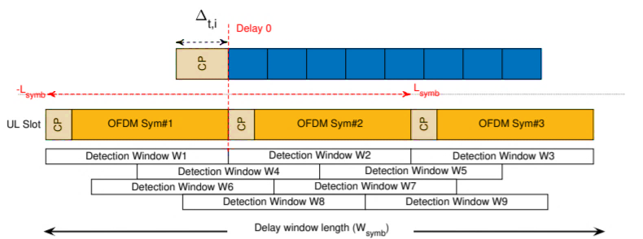

Figure 2‑9 Illustration of the detection algorithm used for both 5G NR RIM-RS designs. The arrival time ∆t,i of one RIM-RS can be any value within [-Lsymb, Lsymb] wrt. the start of the reference detection window W2. Non-overlapping detection windows (W1, W2, W3) are aligned to the UL OFDM symbols and multiple overlapping windows (W4 to W9) are defined to improve detection reliability

This process, including correlation peak based weighted averaging of time domain repetitions, is described as follows based on [10]:

1: Nslots = 0 Number of received slots

2:  Received RIM-RS samples

3: = 0 Number of slots with allocated RIM-RS

4: **for** s = 1 to **do** Loop over slots

5: **for** *n* = 1 to **do** Loop over base sequences

6: **for** *j* = 1 to **do** Loop over detection windows

7: **for** *k* = 1 to **do** Loop over time repetitions

8: Correlation

9:

10: **end for**

11: Peak based weighting

12:

13:

14: **end for**

15:

16: **end for**

17: **if** RIM-RS scheduled in this slot **then**

18:

19:

20: **else if** RIM-RS not scheduled in this slot **then**

21:

22: **end**

23: **end for**

A fixed detection threshold for the correlator output was used in [9], based on Chebyshev’s inequality. This detector provides slightly degraded final detection performance due to non-constant false error probability. We introduce an enhanced receiver algorithm, where we use the information of the distribution of the noise correlation peaks to obtain the proper detection threshold. The distribution is collected from the correlator outputs with inputs containing only noise, obtained when the RIM-RS is not transmitted, to enhance the detection performance and to update the detection threshold based on a given false alarm target as follows [10]:

1: False alarm probability target

2:

3: = sort(**w**)

4: Detection threshold

5: **for** n = 1 to **do**

6:

7:

8: **end for**

9:

#### Sequence generation

See OFDM signal generation for RIM-RS in section 2.1.1.1.2.7.1.

### PRS

|  |  |
| --- | --- |
| Author | Oana-Elena Barbu |
| Related functions | NR_DLPRS |

#### General

To do

# Uplink

## Physical channels

### PUSCH

#### General

See section 2.1.1.1 for further details.

###### OFDM signal generation

OFDM signal generation for all channels except PRACH and RIM-RS is implemented according to TS 38211, section 5.3.1.

OFDM signal generation for PRACH

Same approach as defined in section 2.1.1.1.2.7.1 is followed to generate the OFDM signal generation for PRACH based on the number of repetitions for each PRACH preamble in Tables 6.3.3.1-1 and 6.3.3.1-2 in TS 38211.

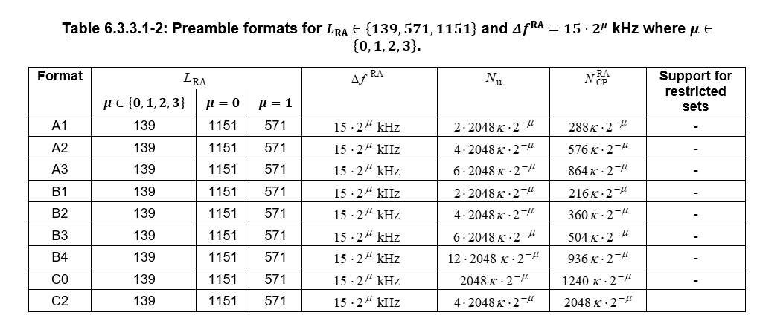

By default, in Korak it is assumed that the OFDM transmitted signal synthesis correspond to IFFT + CP & GP insertion. Therefore, the logic was updated as described previously for RIM studies to keep the same subframe length:



Figure 3‑1 OFDM signal generation for PRACH

As an example of this processing, we illustrate the OFDM signal generation for each preamble format separately assuming mu=0 (15kHz SCS):

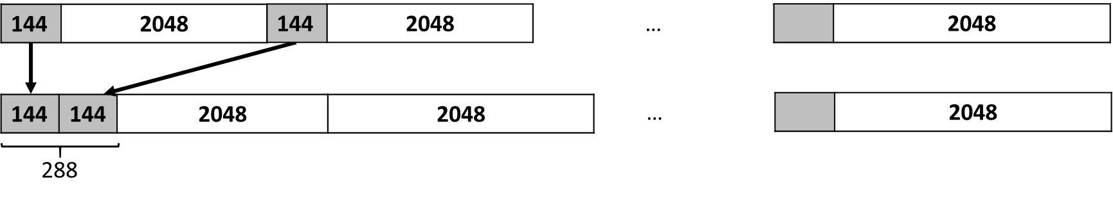

Figure 3‑2 OFDM signal generation for PRACH Format A1



Figure 3‑3 OFDM signal generation for PRACH Format A2

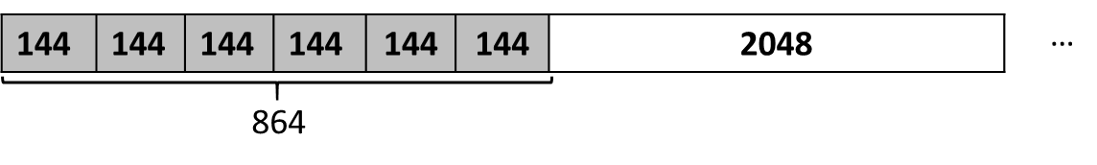

Figure 3‑4 OFDM signal generation for PRACH Format A3

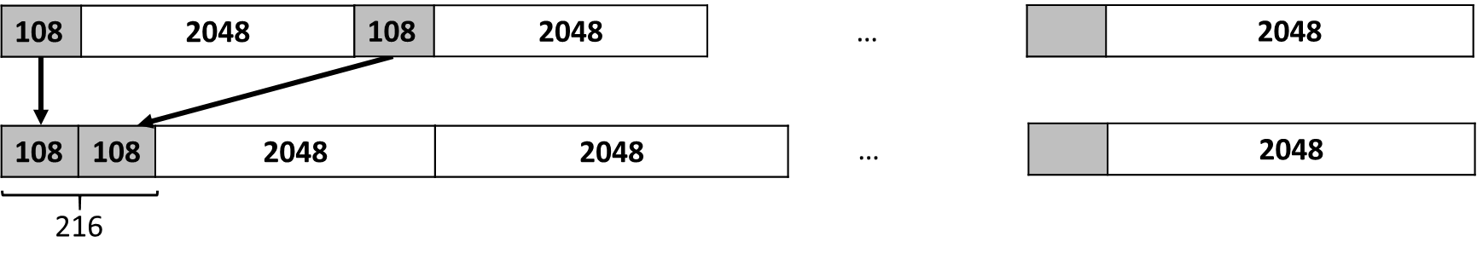

Figure 3‑5 OFDM signal generation for PRACH Format B1. (*) GP=72



Figure 3‑6 OFDM signal generation for PRACH Format B2. (*) GP=216

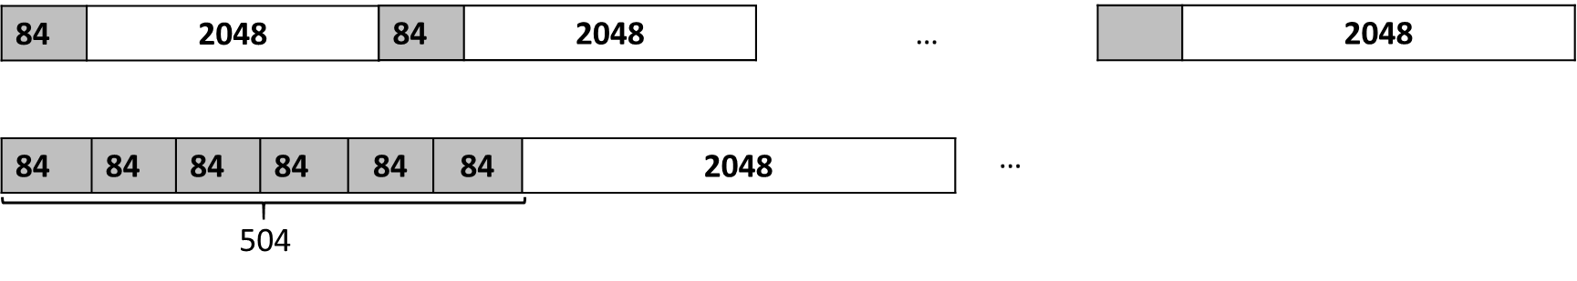

Figure 3‑8 OFDM signal generation for PRACH Format B3. (*) GP=360

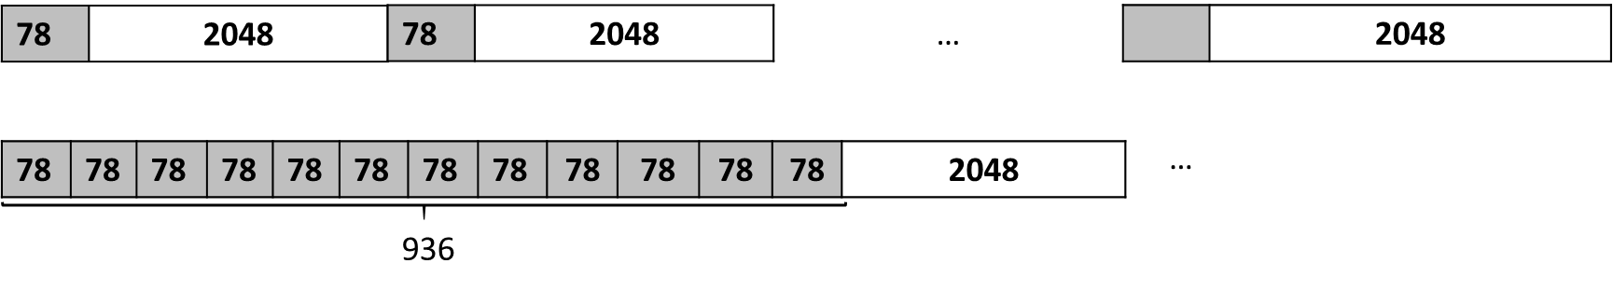

Figure 3‑9 OFDM signal generation for PRACH Format B4. (*) GP=792

#### Channel estimation

The raw channel estimation is described in section 5.1.2.1 and the detector MMSE in section 11.2.

#### Detection algorithm

See section 3.2.1.2

#### Time Offset Estimation

Time offset estimation methodologies are described in section 2.2.1.4 for DMRS, section 3.1.3.3 for PRACH and section 3.2.4.2 for SRS.

#### Time Offset Compensation

Time offset compensation (TOC) is performed once per subframe shifting the received signal or before performing the channel estimation in the wiener filter (practical CE) for all received data symbols based on three possible approaches: ideal TO (assumed known at the receiver), RS TOE (DMRS, CSI or SRS) or PRACH TOE (TA). Therefore, the timing offset correction is based on the timing offset estimate from the previous subframe and the Rx signal () is shifted as:

or the autocorrelation and cross-correlation matrixes as defined in section 6.1.1.1.3 for the wiener interpolation of the channel in Frequency direction are shifted as

where should be calibrated for specific scenario. By default, equals to delay spread of the channel is assumed.

#### Frequency Offset Estimation

To do

#### Frequency Offset Compensation

To do

#### Phase Noise Estimation

To do

#### Phase Noise Compensation

To do

### PUCCH

|  |  |
| --- | --- |
| Author | Pasi Kinnunen |
| Related functions | NR_PUCCH |

#### General

The implementation of this reference signal is based on TS 38.211 Release 15

|  |  |  |  |
| --- | --- | --- | --- |
| **Parameter** | **Description** | **Value** | **Default value** |
| interleaved | interleaved REG to CCE mapping | string | yes | no |
| format | get PUCCH format  For format 0 and 2, the maximum number of OFDM symbols that can be allocated is 2.  For formats 1/3/4, the maximum number of OFDM symbols that can be allocated is 14 (normal CP) or 12 (extended CP). | integer | 0 | 1 | 2 | 3 | 4 |
| resource-index | Resource index for PUCCH dedicated resource (0...15) | string |  |
| list-size | Needs to be define for PUCCHFormat = [2,3,4] | integer | 8 |
| nid | nid should be set: 0-1007  If NID is not configured, physical layer cell identity NCellID is used | integer |  |
| lenACK | lenACK and lenSR define the decoder to use  The HARQ-ACK information is based on LenACK field | integer | 0 |
| lenSR | lenACK and lenSR define the decoder to use  The SR information is based on LenSR field | integer | 0 |
| lenCSI1 | Length of UCI part 1  Needs to be define for PUCCHFormat = [2,3,4] | String | 0 |
| lenCSI2 | Length of CSI part 2 bits, if present  Needs to be define for PUCCHFormat = [2,3,4] | string | 0 |
| cp |  |  |  |
| groupHop | Needs to be define for PUCCHFormat = [0,1] | string |  |
| freqHop |  |  |  |
| csId | Needs to be define for PUCCHFormat = [0,1] | string | 0 |
| occId | Needs to be define for PUCCHFormat = [0,1] | string | 0 |
| modulation | Needs to be define for PUCCHFormat = [2,3,4] | string | QPSK |
| additional-dmrs | Needs to be define for PUCCHFormat = [2,3,4] | string | false |
| group-hopping | Needs to be define for PUCCHFormat = [2,3,4] | string | neither |
| sf | spreading factor  Needs to be define for PUCCHFormat = [2,3,4] | number | 2 |
| intraHop | Indication for intra-slot frequency hopping | string | 'enabled', 'disabled' |
| hopPRB | Index of first PRB after frequency hopping | string | 0 |
| M | interlace | string |  |
| fOCC |  | number | 0 |

### PRACH

#### General

|  |  |
| --- | --- |
| Author | Elena Peralta |
| Related functions | NR_PRACH |

The implementation of this reference signal is based on TS 38.211 Release 15

PRACH class was at first implemented in the DL branch ok Korak and it is kept there for legacy purposes. The physical channel is currently available in UL and it should be removed from DL in future.

|  |  |  |  |
| --- | --- | --- | --- |
| **Parameter** | **Description** | **Value** | **Default value** |
| L | root sequence length | integer | 139 | 839 (Note 1) |
| zeroCorrelationZoneConfig-index-for-Ncs  ||  cyclic-shifts-per-root | See (Note 2) for NCS definition | integer |  |
| format | Preamble format. Defined according to tables 6.3.3.1-1 and 6.3.3.1-2 in 38211-g00. | string | A1 | A2 | A3  B1 | B2 | B3 | B4  0 | 1 | 2 | 3 |
| idft_size | IFFT at Rx side to increase detection resolution | integer | - |
| nbr-preambles | Number of preambles | integer | 64 |
| preambleGeneration | See (Note 3) | string |  |
| i-logical-root-sequence-index | Used to get the sequence number 'u' corresponding to the logical index i (in increasing order of 'i').  TS 38211  Table 6.3.3.1-3 for L=839  Table 6.3.3.1-4 for L=139,  Table 6.3.3.1-4A for L=1151  Table 6.3.3.1-4B for L=571 | integer | 0 |
| set | For restricted and unrestricted sets. | String | unrestricted | restrictedA | restrictedB |

**(Note 1)**

In release 16, L=571 and L=1151 have been added for NR-U

**(Note 2)**

There are two possible configurations for the Ncs definition:

1. <*zeroCorrelationZoneConfig-index-for-Ncs>* is defined (spec based)

Ncs is defined according to tables 6.3.3.1-5 and 6.3.3.1-6 and 6.3.3.1-7 in 38211-g00 based on numerology (L). For instance:

*<zeroCorrelationZoneConfig-index-for-Ncs>* equals to 7corresponds to Ncs = 13 for L=139

*<zeroCorrelationZoneConfig-index-for-Ncs>* equals to 14 corresponds to Ncs = 46 for L=139

1. <*cyclic-shifts-per-root>* is defined (not spec based)

Ncs is defined according to the number of cyclic shifts per root (Nv). For instance:

*<cyclic-shifts-per-root>* equals to 9 corresponds to Ncs=15.

**(Note 3)**

The preambles can be generated randomly per TTI, which it is expected to result in a better detection performance or based on a fixed root sequence for testing purposes (mainly RAN4 work).

1. *<preambleGeneration>* correspond to *“random-preamble-mapping”*

In this case a random preambleMapTable is generated in each transmission. Therefore, Parameters‘*i- logical-root-sequence-index’* and *‘set’* don’t need to be defined, and the sequence number set ('u' or 'u_set') is chosen randomly per TTI.

1. <*preambleGeneration>* correspond to *“fixed-preamble-mapping”*

In this case a fixed preambleMapTable is generated in each transmission (spec based). Therefore, next parameters should be defined: *i-logical-root-sequence-index* and *set,* and the sequence number set ('u' or 'u_set') is fixed for the whole simulation run.

#### Detection algorithm

|  |  |
| --- | --- |
| Author | Elena Peralta, Toni Levanen |
| Related functions | NRPrachSequenceDetector |

- Step 1: Combine information over repeated PRACH symbols (coherent accumulation). Note: study if the performance improves splitting the repetitions in subgroups. (complete formulas)

for is the received signal and is the reference signal of length L.

- Step 2: Normalized mean based on maximum peak values for each antenna

- Step 3: Estimate noise level by ignoring the highest peaks

- Step 4: Preamble detection based on maximum peak detected:

1: **if** ~empty(cyclic-shifts-per-root) **then**

2: Nv = cyclic-shifts-per-root Number of cyclic shifts

3: Ncs = floor(L/ Nv) Cyclic shift

4: Nr = ceil(64/Nv) Number of roots

5: **else if** ~empty(zeroCorrelationZoneConfig-index-for-Ncs) **then**

6: Ncs from tables 6.3.3.1-5 and 6.3.3.1-6 and 6.3.3.1-7 in 38211-g00

7: Nv = floor(L/Ncs)

8: Nr = ceil(64/Nv)

9: **end**

10: wstart =(0:Nv-1)*(idft/Nv)+1 Indices of search windows

11: Empirical detection threshold

12: **for** r = 1 to **do** Loop over number of roots

13: **for** *s* = 1 to **do** Loop over number of cyclic shifts

14: index= floor(wstart(s)) Start sample of searching window

15: peak=max(CIR[index:index+Ncs+1]) Maximum peak

16: **if** peak > **then**

17: **if** transmitted preamble == detected preamble

18:

19: **else if** transmitted preamble != detected preamble

20:

21: **end**

22: **end**

23: **end for**

24: **end for**

#### Time Offset Estimation

|  |  |
| --- | --- |
| Author | Elena Peralta |
| Related functions | NRPrachSequenceDetector |

Assuming the preamble is correctly detected, the time offset is calculated based on the samples difference from the detected peak.

- Step 5: Based on maximum peak, perform time offset estimation. One CIR example case without TO and TO=0.66us is illustrated in Figure 3‑1 based on following numerology:

, , , ,

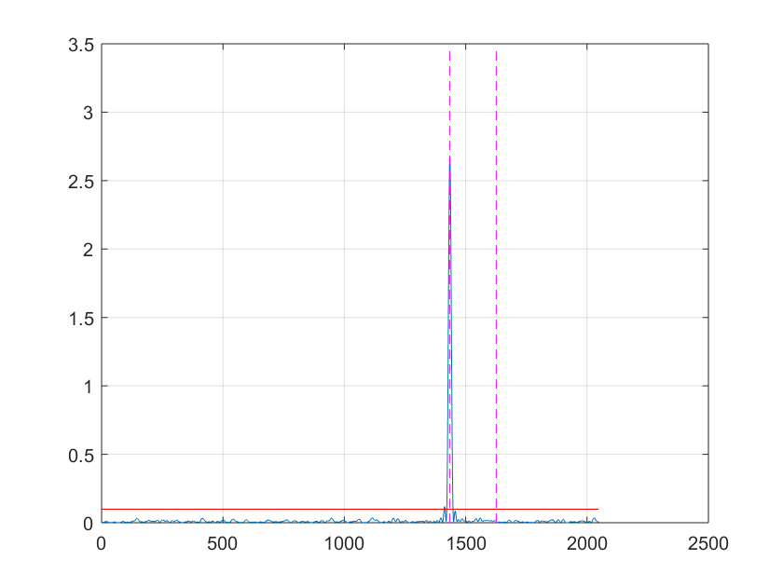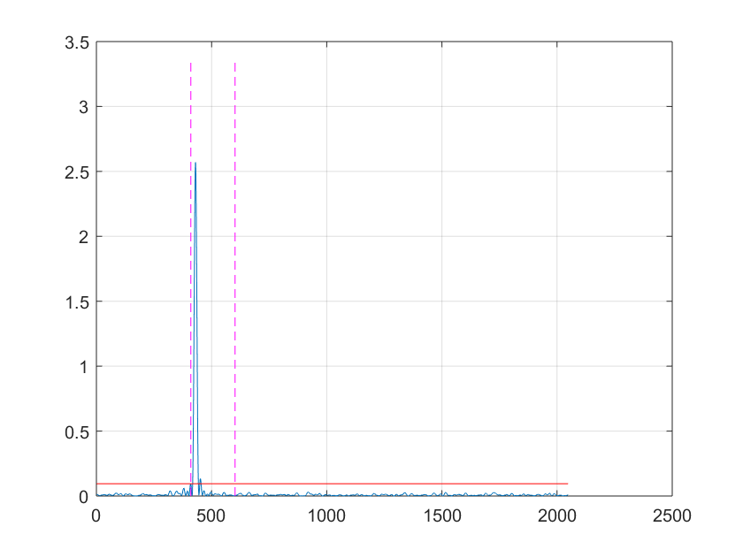

Figure 3‑10 Example CIR without TO (left) and with TO=0.66us (right), where dot pink lines define the search window for specific root sequence and cyclic shift

- Step 6: Give estimated offset as input to wiener CE. Fixed value per SNR value based on mean (TOE).

## Physical reference signals

### DMRS for PUSCH

See section 2.2.1

#### Sequence generation

#### Detection algorithm

See section 2.2.1.3

#### Time Offset Estimation

See section 2.2.1.4

#### Frequency Offset Estimation

See section 2.2.1.5

### PTRS for PUSCH

#### General

See section 2.2.2

### DMRS for PUCCH

#### General

See section 2.2.3

### SRS

#### General

|  |  |
| --- | --- |
| Author | Jorge Morte |
| Related functions | NR_SRS.m |

The implementation of this reference signal is based on TS 138.211 V15.7.0.

At this point, uplink is not fully implemented and working seamlessly on Korak. Therefore, the approach is to use downlink like PUSCH and PRACH to enable NR-SRS. This is temporary, and as soon as uplink is available, this physical signal must be migrated.

To reduce the implementation impact on downlink, NR-SRS can be used with single-link-model and <cmw-generic-subframe> by including the NR-SRS configuration within the <radio-resource-control> element of the basestation.

|  |  |  |  |
| --- | --- | --- | --- |
| **Parameter** | **Description** | **Value** | **Default value** |
| number-ports | Number of antenna ports in the SRS resource set | integer | 1 |
| number-ofdm-symbols | Consecutive OFDM symbols in the SRS resourse set | integer | 1 |
| transmission-comb | Separation in subcarriers between SRS's REs | integer | 2 |
| transmission-comb-offset | Transmission Comb offset | integer | 0 |
| symbol-offset | Offset in OFDM symbols from the end of the slot | integer | 0 |
| subframe-period | Period in slots of the SRS resourse set | integer | 5 |
| subframe-offset | Offset in slots of the SRS resource set | integer | 0 |
| bandwidth | Parameter B_SRS from Table 6.4.1.4.3-1 | integer | 0 |
| bandwidth-config | Parameter C_SRS from Table 6.4.1.4.3-1 | integer | 0 |
| hopping-bandwidth | Parameter b_hop to configure frequency hopping | integer | bandwidth |
| hopping-type | Type of sequence hopping | 'neither' | 'groupHopping' | 'sequenceHopping' | 'neither' |
| repetition-factor | Repetion factor of the SRS resource set | integer | 1 |
| freq-domain-pos | High layer parameter freqDomainPosition | integer | 0 |
| cyclic-shift | Cyclic shift parameter | integer | 0 |
| sequence-id | SRS sequence identity | integer | 0 |
| power-boost | Power boosting in dB | integer | 0 |

#### Time Offset Estimation

|  |  |
| --- | --- |
| Author | Jorge Morte |

To do

# Synchronization and tracking

|  |  |
| --- | --- |
| Author | Panayiotis Papadimitriou, Andrei Malkov, Tero Ihalainen, Heikki Berg |

## PSS and SSS generation and tracking

Figure 4‑11 shows the logic for intial acquisition, timing/frequency tracking.

1The figure is initially copied from the figure in document “L1 Algorithm and Simulator, Panayiotis Papadimitriou, Andrei Malkov, Tero Ihalainen, Heikki Berg, Nokia”.

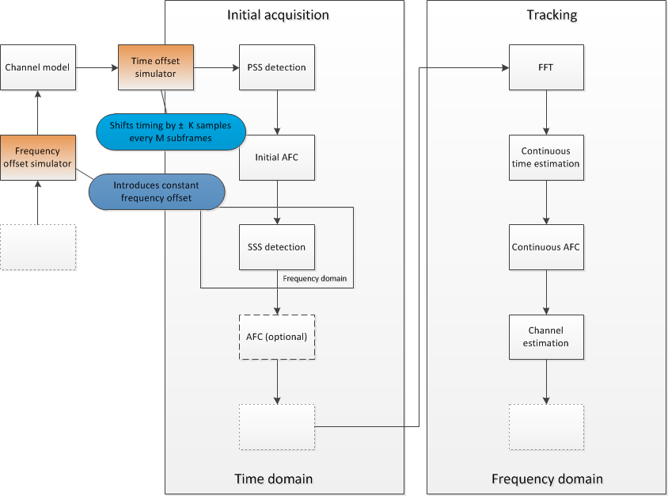

Figure 4‑1 Initial Acquisition, Timing/Frequency Tracking

## Efficient SSS Detection

In this section we discuss an efficient SSS detection method, that has certain benefits than the exhaustive search, i.e. correlation over all possible 168x2 SSS sequences within a radio frame of 10ms.

The sequence d(0), ..., d(61) used for the second synchronization signal is an interleaved concatenation of two length-31 binary sequences. The concatenated sequence is scrambled with a scrambling sequence given by the primary synchronization signal. The basic formulation of the sequence d(0), ..., d(61) is given in 3GPP TS 38.211.

Secondary Synchronization Signal (SSS) is an interleaved concatenation of two length-31 binary sequences. Therefore two correlators of length 31 each, give the sufficient statistics for the detection of the SSS. In this way the detection yields the estimated m0 and m1 which give further benefits. Two flavors of the algorithm can be used (among others):

* coherent (utilizing channel estimation from detected PSS sequence)
* non-coherent using partial correlation (correlation over subsequent blocks)

### Coherent SSS Detector

This detector can be summarized as follows. Given *y* the received SSS signal after FFT, and channel compensation, of size N × 62, calculate

# Covariance Estimation from Common Reference Symbols or Demodulation Reference Symbols (CSI/DMRS)

### CRS Based Channel Estimation at High Level

|  |  |
| --- | --- |
| Author | Heikki Berg, Tero Ihalainen, Panayotis Papadimitrou, Elena Peralta, Hesham Elgendi |

Covariance matrix of received signal is needed in interference-suppressing demodulation, that is, in interference-aware receivers, which will be described in Section 11.6.

In this section, a high-level description of CRS based channel estimation is given. A block diagram which shows the interconnections between different subroutines on subframe time scale is depicted in Figure 5‑1. It shows the processing for a specific transmit antenna port *pTx* - receive antenna *pRx* pair. The shown channel estimator structure is dublicated = × times for different antenna pairs. The different estimators are configured to operate independently and their associated computations can therefore be carried out in parallel.

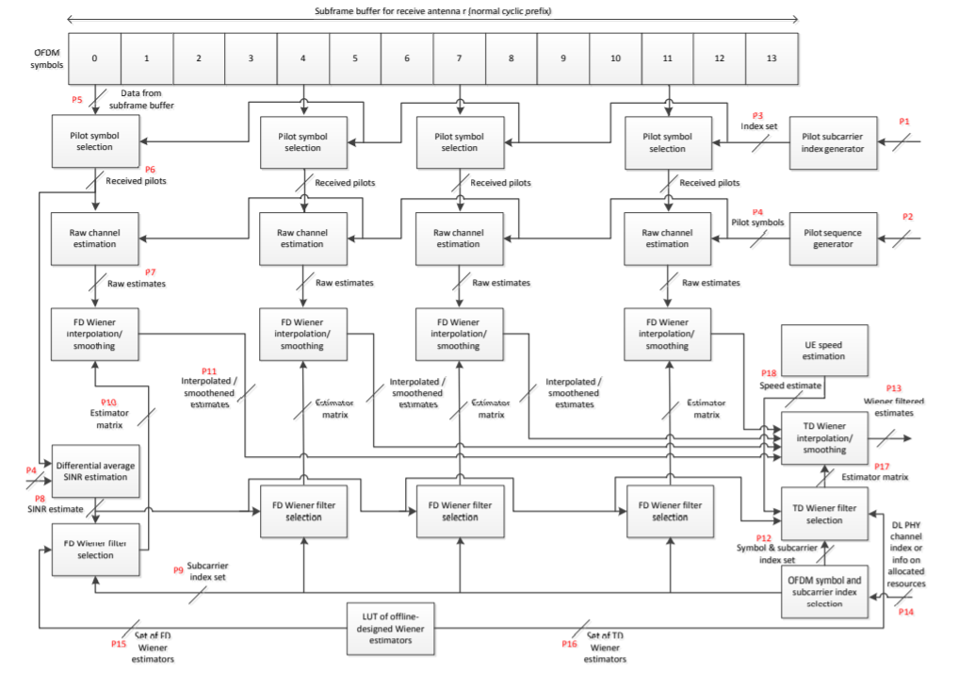

Figure 5‑1 CRS based channel estimation at high level

For a given (*pTx*, *pRx*)-pair the processing can be described as follows. The received signal in each receive antenna branch *pRx* is stored into a sample buffer after the FFT and the guard band removal. Received samples of antenna *pRx* are stored per OFDM symbol manner into a length- vector . Each of these vectors is attached with side information (*kf , ksf , ks*) on its associated frame, subframe, and OFDM symbol numbers, denoted by *kf , ksf ,* and *ks*, respectively.

There are two subroutines that are evoked once for each OFDM symbol. They are referred to as CRS Pilot Sequence Generation and CRS Pilot Pickout. These functional units are used for producing pilot symbols and subcarrier indexes, respectively, of the reference signal sequence for the transmit antenna port *pTx* in hand at corresponding pilot-carrying OFDM symbol instants. CRS Pilot Pickout comprises the pilot subcarrier index generation and pilot symbol selection blocks shown in Figure 5‑1. The execution of both units is event-triggered and subject to validation of the symbol number *ks* against the transmit antenna port configuration. Only in case of valid symbol numbers, these blocks will produce outputs and trigger the next algorithms. Otherwise, nothing happens. Both blocks get the number of DL resource blocks, , the cell ID, , the index of the transmit antenna port *pTx*, and the (*kf , ksf , ks*) side information as their input parameters. The CRS Pilot Pickout -block additionally gets the received sample vector as its input and returns a length- received pilot vector carrying samples of the reference subcarriers. The Pilot Sequence Generation outputs a length- pilot symbol vector .

Once the vectors and are available, they will trigger two independent subroutines, namely Differential SINR Estimation and Raw Channel Estimation, that can be computed in parallel. The Raw Channel Estimation, which is discussed in detail in coming sections, provides initial channel estimates at CRS pilot frequencies for the pilot carrying OFDM symbols. Figure 5‑1 shows the situation for transmit antenna ports 0 and 1, therefore OFDM symbol indexes 0, 4, 7, and 11. Regarding the different pilot symbols and their associated processing, it is important to note that the depicted processing chains do not comprise different algorithm blocks but should be interpreted as consisting of merely different runs of the same algorithms with different parameters and/or data. SINR estimation enables selecting an appropriate frequency domain (FD) Wiener estimation filter for smoothening/interpolation of channel estimates at/between pilot subcarriers based on the raw estimates. Average SINR estimation and FD Wiener filtering algorithms are described in coming sections.

### Raw Channel and Covariance Estimation

#### Raw Channel Estimation

The actual reference signal transmitted in pilot subcarriers are complex numbers known to the receiver. The reference signal is generated by QPSK modulating the output of linear shift feedback register (LSFR) into an array in advance. Received reference subcarriers *f* are given by:

where the is the unknown complex channel coefficient vector containing the coefficients from transmit antenna *p* to receive antennas . is the transmitted reference subcarrier from transmitter antenna *p*. ***n*** is unknown complex noise vector. is the set of reference subcarrier indexes for OFDM symbol *k* transmitted from antenna port *p* and the set of OFDM symbols containing pilot subcarriers from antenna port p. Number of rows in vector equals to number of receiver antennas . The channel coefficients can be solved as:

Notice here that the term divides each of the elements in the vector . The division of two complex numbers can be accomplished by multiplying the numerator and denominator by the complex conjugate of the denominator. Fortunately for the LTE system the magnitude of transmitted reference subcarriers is always unity, therefore the complex division operation can be rewritten as:

#### Covariance Matrix Estimation

##### Single Covariance Estimate

The interference covariance matrix, to be utilized for interference-suppressing demodulation, can be estimated by advanced UE receivers from interference+noise samples. In the LTE branch, there are two practical approaches, referred to as the **residual and the differential estimation schemes**, that can be used to obtain interference+noise samples based on which raw covariance matrix estimates can be derived. Besides, in the NR branch, one more estimation scheme is added referred to as the **enhanced estimation method**.

1. Residual interference for the pilot subcarriers is given by:

where the desired signal contribution (from the serving eNB) of the transmitted pilot symbol is subtracted from the received observation vector based on the knowledge of the estimated channel vector .

1. Alternatively, interference+noise samples can be created differentially from the received samples at neighboring pilot subcarriers (contiguous in frequency) as follows:

Note that in contrast to the residual technique, the differential estimation can be performed in parallel and independently of the channel estimation. This is due to the fact that the expression above requires no explicit knowledge of the complex channel gains but instead relies on the underlying assumption that the pilot spacing in frequency (6 subcarriers for a given transmit antenna port) is sufficiently small compared to the channel coherence bandwidth. In case this condition is fulfilled, i.e., channel transfer function remains approximately unchanged for the two contiguos pilot subcarriers (≈ the subtraction in the equation above effectively and adequately removes the desired signal component from the received observation vector. Consequently, provides a sample estimate/measurement of the interference+noise as experienced by the receiver. × raw covariance estimates for reference subcarriers are then given by:

A block diagram of differential interference+noise covariance matrix estimation is depicted in Figure 5‑3. In the following, the different processing phases are described in detail.

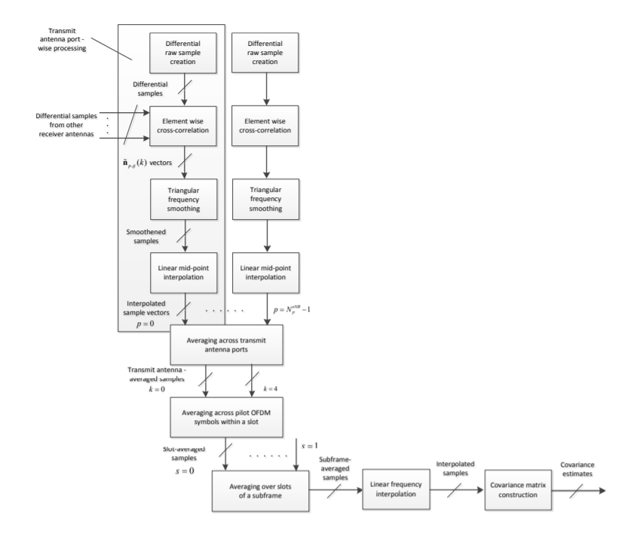

Figure 5‑2 Simplified block diagram of differential CRS based interference+noise covariance estimation

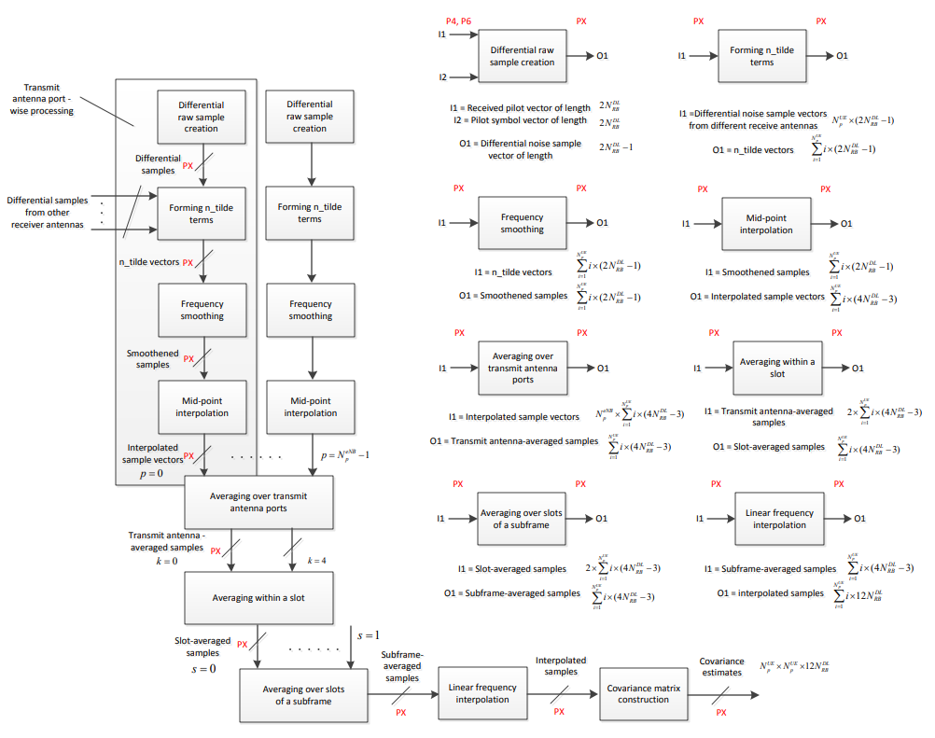

Figure 5‑3 Detailed block diagram of differential CRS based interference+noise covariance estimation

###### Practical Aspects of Covariance Calculation

Considering the memory access and computational complexity issues, it is beneficial to pay attention to a number of aspects in covariance calculation.

Rather than calculating the raw covariance matrices separately for different pilot positions () using corresponding interference+noise measurement vectors , as shown in previous equation, one may instead do the following. By stacking the interference+noise measurements for antenna port *p* receive antenna wise to different vectors:

where denote residual/differential interference+noise measurements of symbol , element wise cross-correlation can be evaluated. Now, let us assume = 2 receive antennas for illustration purpose. Then, the (1, 1), (2, 2) and (2, 1) elements of the 2-by-2 raw covariance matrices can be obtained, respectively, as:

where ¤ denotes element-wise multiplication operator and denotes a complex conjugate. One should note that, it is possible to reduce the required computations by making use of the fact that the resulting diagonal elements are in fact real-valued. Taking this into account, we end up to the following expression:

Another mean to lower the computational complexity is to utilize the complex conjugate symmetry of the off-diagonal elements of the raw covariance matrix. For instance, in the above considered 2-by-2 case, the (1, 2) elements could be straightforwardly obtained by changing the signs of the imaginary terms of . It is possible however to postpone the evaluation of the upper triangular elements of the estimated covariance matrix to take place only after the final estimates of the lower triangular elements have been calculated. This also reduces the amount of memory required to store the covariance estimates. By exploiting this trick, the evaluation of the cross-correlation terms in general results in length-S vectors for each transmit antenna port *p.*

1. The so-called enhanced estimation method (or network assisted covariance estimation) assumes knowledge about the reference signals used in neighboring UEs (or gNBS) in contrast to the differential methodology, where there is no knowledge of interfering links.

Therefore, leaving out algorithms for interpolating and smoothing raw interference plus noise covariance estimates, the actual covariance matrix fed to the MMSE-IRC receiver for demodulation using the differential methodology is defined as follows:

where is the signal power. On the other hand, relying on the knowledge obtained from the reference signals used in neighboring UEs (or gNBs), the effective channel of interfering links can be calculated. For the enhanced estimation method, the generic form for the interference covariance matrix is defined as:

where N is the number of interferers and is the noise power. Thus, the actual covariance matrix used for demodulation for the target UE (t) and interfering signals (i) is defined accordingly as:

##### Frequency Domain Smoothing

Raw covariance matrices defined as are smoothed in frequency domain over N = 5 neighboring pilot carriers with a normalized triangular window defined as

where

and

which is appropriate normalization for the smoothing window. Smoothed covariance estimate for subcarrier *f* is then

where

thus is unbiased estimate for the covariance matrix for subcarrier *f* based on the transmitted signal from antenna *p*.

In the band edge, for instance for *f* = 0, the “missing” covariance estimates are mirrored from the positive side, thus

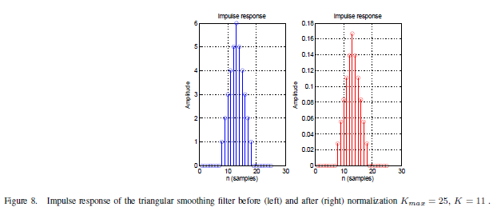

Figure 5‑4 Impulse response of the triangular smoothing filter before (left) and after (right) Kmax=23, K=11

###### Practical Aspects of Smoothing Filtering:

After the diagonal elements and lower triangular elements of the raw covariance matrices have been calculated, frequency domain smoothening is carried out using a real-valued length-N even-order FIR filter. Due to its triangular impulse response, the coefficients of the smoothening filter show symmetry with respect to the center tap. This symmetry can be exploited to lower the computational complexity of the filtering. The number of multiplications required per input sample can be reduced almost by factor of two by implementing the filter in the following form

##### Frequency Domain Linear Mid-Point Interpolation

As an example, there is an offset of three subcarriers between consecutive OFDM symbols with pilot subcarriers. Visually we can see this from Figure 5‑4. In order to average the covariance matrix in time across the OFDM pilot symbols, we need to interpolate, based on the smoothed covariance matrix estimates separated by 6 subcarriers in frequency, to every 3 subcarriers. This operation effectively increases the frequency resolution of the covariance estimates by a factor of 2. The mid-point interpolated covariance matrices are given by

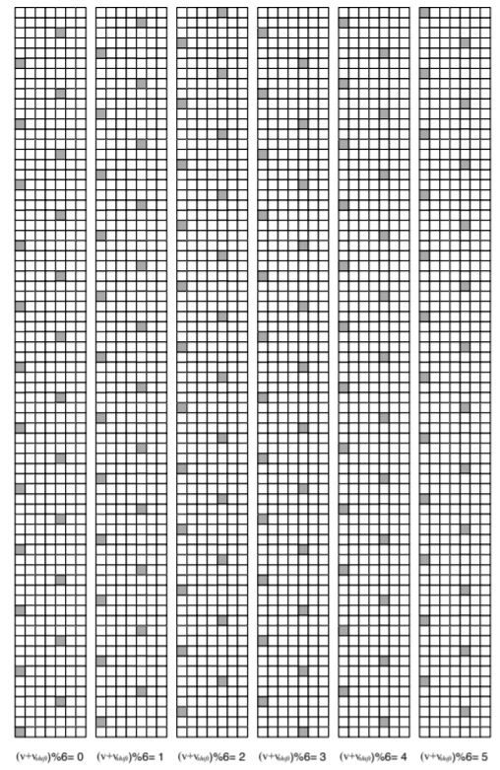

Figure 5‑5 Common reference signal subcarrier mapping for antenna port p = 0 for all values of (v + vshift)%6 (normal cyclic prefix)

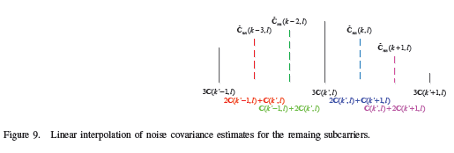

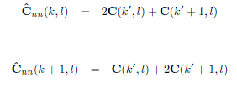

Figure 5‑6 Linear interpolation of noise covariance estimate for the remaining subcarriers

##### Averaging Across Transmit Antennas

Since the interference covariance matrix is for additive interference it is independent of the transmit antennas. Thus the accuracy of the estimates can be increased by averaging the estimate over transmit antenna ports:

is the augmented set of subcarriers, thus every third, having a covariance estimate for OFDM symbol *k*

##### Time-Domain Averaging of Covariance Estimates

The covariance estimates are averaged in time. First, mean of the estimates of the same subframe *s* are averaged linearly as

Then the time-domain averaged covariance estimate for slot s is given by simple update equation of

where α is the forgetting factor. It is required that 0 ≤ α ≤ 1 in order to guarantee stability of the update equation. In the case of discontinuos transmission, where mobile station receives one subframe every once in a while, α should be 1, which means that past experience is not valued in the update equation. In continuos reception α = 0.3 is used in stable state (in and after 3rd received slot). When continuos reception is started the values α = 1.0 and α = 0.5 are used for the first and the second slots

##### Frequency-Domain Linear Interpolation of Covariance Estimates

Covariance estimates are interpolated linearly between subcarriers of the set in runtime as the allocated subcarriers are known for demodulation.

#### Differential Average Variance Estimate

The Wiener estimator, used for interpolation of complex channel gains of data-carrying resource elements, is selected based on estimated average signal-to-interference plus noise ratio

where denotes the differential estimate of interference plus noise variance, estimated based on the *k*th CRS pilot symbol of the *r*th receive antenna branch. The variance estimate is obtained as the mean (sample average) of corresponding diagonal terms of raw covariance matrix and is given by

where the divider is the number of terms used for averaging. Averaging over different transmit antenna ports is assumed. The SINR estimate is used to select the closest Wiener interpolation filter from a set of 3 possible pre-calculated Wiener filters optimized for signal-to-interference plus noise ratios of 5, 15 and 25 dB. One important aspect that deserves to be emphasized is that differential covariance matrix estimation and raw channel estimation algorithms can be executed in parallel. The frequency domain Wiener interpolation/smoothing, the algorithm which is described in details in the following Chapter, can be triggered as soon as the differential variance estimate has been evaluated and raw channel estimates become available. The more accurate and detailed estimation of the interference covariance, required to enable interference-sup.

#### Generic covariance estimation parameterization in Korak

|  |  |  |  |
| --- | --- | --- | --- |
| **Parameter** | **Description** | **Value** | **Default value** |
| average-across-rs-symbols-within-subframe | Average covariance data over time | string | yes | no |
| average-across-tx-ports | Average covariance data over APs | string | yes | no |
| average-iono-across-rx-antennas | Average IoNo over Rx | string | yes | no |
| average-iono-over-time | Average IoNo data over time | string | yes | no |
| direction | Direction of differential neighbours. Effective only for differential algorithm. |  | freq | time | |
| estimate-iono | Get IoNo estimate | string | yes | no |
| estimation-method | Method for raw covariance sample creation. | String | differential | residual | enhanced |
| interpolate-covariance | Interpolate covariance data in frequency | string | yes | no |
| iono-granularity-in-rb | Granularity in resource blocks | integer | - |
| rs-type | Currently supported RS signals for NR covariance estimation | string | nr-pucch-dmrs |nr-pdsch-dmrs  | nzp-csi-rs |
| smooth-covariance | F-D smoothener | string | yes | no |
| smoothing-filter-length | Length of the F-D smoothing filter. Odd integer value is assumed. | integer | 5 |
| smoothing-filter-type | Type of the F-D smoothener | string | triangular |
| use-wideband-iono | Wideband IoNo estimation | string | yes | no |

# Channel Estimation from Common Reference Symbols or Demodulation Reference Symbols (CSI/DMRS)

|  |  |
| --- | --- |
| Author | Heikki Berg, Tero Ihalainen, Panayotis Papadimitrou, Elena Peralta, Jorge Morte |
| Related functions | GeneralizedWienerEstimator.m |

### The Wiener Estimator

Every sixth subcarrier in frequency direction is a pilot subcarrier. The channel in between has to be interpolated from the measurements taken from the pilot positions. From equations where we obtain and (below) we already know that interpolation coefficients do not depend on absolute positions of channel measuremens but on the relative distance of the measurements. In addition, the pilot subcarrier allocation pattern (in frequency direction) is similar in all transmit antenna ports. Therefore it is possible to construct a single frequency domain (FD) Wiener interpolator matrix and use selectively different rows of the matrix depending on the pilot shift (*v + vshift*) %6 for given antenna port. The basic structure of our interpolator utilizes the pilot measurements from six consecutive physical resource blocks according to Figure 6‑1. The measurements are grayed and numbered and our interpolator needs to interpolate the white ones and smoothen the gray ones. We are augmenting the estimator by extra 5 locations, numbered from *c(−1)* to *c(−5).* Then depending on the actual value of pilot shift (*v + vshift*) %6 we drop 5 − (*v + vshift*) %6 first and (*v + vshift*) %6 last rows of the precalculated estimator matrix before doing the actual interpolation/smoothening.

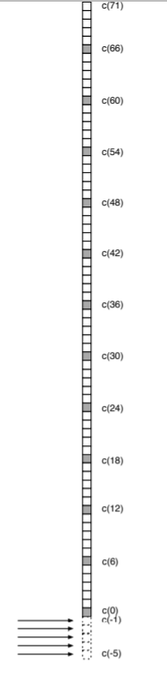

Figure 6‑1 Subcarrier numbering for Wiener interpolator

In theory, Wiener interpolator/smoothener depends on the signal-to-noise ratio of the signal to be interpolated. However, the practice has shown the filter to be quite unsensitive to signal-to-noise ratio estimation error. Therefore we will precalculate 3 different Wiener filters offline, and use the closest one of them based on the estimated signal-to-noise ratio

#### Derivation of FD Wiener Filter

We look for a linear estimator such that a finite number of samples are estimated from a finite number of measurements with linear estimation matrix ***B*** of size L × M. The estimator is given by

Wiener estimator minimizes the mean square error (MMSE) for each sample so that

According to the orthogonality principle this is satisfied if

where and denotes for a Hermitean transpose. By substitution we can write

and we end up with Wiener-Hopf equation given by

which can be written as

where and . Esimation matrix can be solved as

##### Two Dimensional Autocorrelation Function of the Channel

Complex fading amplitudes at certain frequency and time is given by

where is the time-variant channel transfer function. The measurements are noisy samples of the channels, that is,

where is complex AWGN with variance . It is assumed that model for is WSSUS, thus the two dimensional autocorrelation function

Noise and the fading are statistically independent, thus the elements of the matrix are given by

and the elements of the matrix are given by

##### Wiener Interpolation of the Channel in Frequency Direction

If we utilize only frequency domain measurements from the channel transfer function and assume uncorrelated scattering the process , the frequency correlation function is given by

which is Fourier transform of the delay power spectrum. If we assume the delay power spectrum is exponentially decaying [11] (fair assumption) the frequency autocorrelation function is given by

The autocorrelation matrix has the elements

and the cross correlation matrix elements

##### Generic FD Wiener parameterization in Korak

|  |  |  |  |
| --- | --- | --- | --- |
| **Parameter** | **Description** | **Value** | **Default value** |
| designType | specify whether the SDR channel estimator matrices are designed on-fly or if estimators are selected among those stored into an offline-designed (pre-calculated) look-up table instead | string | on-fly-design | pre-designed-lookup-table |
| fdCorrFcn | There are five practical approaches, referred to as the ‘fdCorrMdl-1’, ‘fdCorrMdl-2’, ‘fdCorrMdl-3’, ‘fdCorrMdl-4’, ‘fdCorrMdl-5’ (Note 1) | string | 0 | 1 | 2 | 3 | 4 |
| fdWienerTyp | frequency-domain Wiener filter design | string | config-flex-a NR-PDSCH-DMRS-REL15|NR-PSCH-DMRS-REL15 |config-flex-u |preconfig-1 |preconfig-2 |
| flex-config-dsg-prms-1 | Vector of indices, which corresponds to RS RE positions within a PRB in frequency direction. | integer |  |
| flex-config-dsg-prms-2 | 1st value: number of scs per PRB (blocksize for Wiener)  2nd value: number of PRBs, from which RS REs are taken for an input, e.g., filter BW in PRBs.  3rd value: number of extra Wiener output locations (can be same as maximum value in: "flex-config-pshift-per-layer") | integer | - |
| flex-config-ppfir-prms | 1st value: number of total input pilots. E.g. length(flex-config-dsg-prms-1) * 2nd value of "flex-config-dsg-prms-2" (2) = 12  2nd value: number of extra Wiener output locations (can be same as maximum value in: "flex-config-pshift-per-layer")  3rd value: number of pilots for low sub-band edge processing  4th value: number of pilots for high sub-band edge processing  5th value: pilot spacing in subcarriers | integer | - |
| fii | This parameter defines the assumed frequency coherence bandwidth of the channel. | integer | - |

(Note 1) Frequency correlation models:

* + fdCorrMdl-1

If we assume the delay power spectrum is exponentially decaying [11] (fair assumption) the frequency autocorrelation function is given by

* + fdCorrMdl-2
  + fdCorrMdl-3

Similar approach as case *fdCorrMdl-1* but with design SNR offset.

* + fdCorrMdl-4

Similar approach as case *fdCorrMdl-1* but considering ideal time offset compensation or DMRS time offset estimation and compensation as follows:

* + fdCorrMdl-5

Similar approach as case *fdCorrMdl-4* but considering PRACH time offset estimation and compensation. Therefore, one TOE value per SNR point.

Conditions not to crash Wiener. The following two formulas should result in same number!

* 1st value of "flex-config-dsg-prms-2" * 2nd value of "flex-config-dsg-prms-2" + 3nd value of "flex-config-dsg-prms-2" = X
* 2nd value of "flex-config-ppfir-prms" + 3rd value of "flex-config-ppfir-prms" + 4th value of "flex-config-ppfir-prms" = X

#### Calculation of FD Wiener Interpolator Coefficients for LTE CRS

We will use 12 consecutive channel measurements in our Wiener interpolator/smoothener. In addition we have selected τm = 0.75e−6 , which gives approximately 212kHz coherence bandwidth [11] pp.51. The measurements are given by

where **n** is AWGN noise vector of variance σ2 . The vector of length 77 (=72+5) to be estimated is

thus the measurement at pilot positions *f* are smoothed as well. 12-by-12 autocorrelation matrix is given by

and the 77-by-12 cross-correlation matrix by

The estimator matrix is given by

and

Additionally, in OFDM based systems usually no signal is transmitted on DC-subcarrier. In some of these systems, as in LTE, the distance between two closest pilots on different side of DC-subcarrier is actually one subcarrier greater than it is otherwise. Therefore, the estimator, which utilizes pilots on different sides of DC-subcarrier should be modified accordingly. However, this error is neglectable and can usually be ignored.

The 3 different Wiener interpolators {**B**5, **B**15, **B**25} are calculated for SNR’s 5, 15 and 25 by inserting as the variance to the diagonal of the 12-by-12 autocorrelation matrix equation and applying equation . The correct interpolator is selected in “runtime” based on the estimated signal-to-noise ratio (see Differential Average Variance Estimate section 5.1.2.3)

##### Design of 1, 2, 3 and 4 PRB estimators

The design methodology described above for 6-PRB estimator is used with the corresponding measurement and estimate vectors and auto- and cross-corrlation matrices.

###### 4-PRB estimator

Length-8 measurement vector

length-53 vector to be estimated

8-by-8 autocorrelation matrix

53-by-8 cross-correlation matrix

###### 3-PRB estimator

Length-6 measurement vector

length-41 vector to be estimated

6-by-6 autocorrelation matrix

41-by-6 cross-correlation matrix

###### 2-PRB estimator

Length-4 measurement vector

length-29 vector to be estimated

4-by-4 autocorrelation matrix

29-by-4 cross-correlation matrix

###### 1-PRB estimator

Length-2 measurement vector

length-17 vector to be estimated

2-by-2 autocorrelation matrix

17-by-2 cross-correlation matrix

#### Wiener Interpolation/Smoothening with Example

An example of the Wiener Interpolator/Smoothener for pilot shift (v + vshif t) %6 = 0 is depicted in Figure 6‑2 for 6PRB and Figure 6‑3 for other configurations. As pilot shift is 0 we shall not use first 5 rows of interpolation matrix **B**SNR at all as there are no data carriers below lowest pilot carrier index. Multiplication of estimator matrix **B**SNR rows 6 to 38 with raw channel estimate vector of

produces interpolated channel estimates

This is depicted by the left hand side of the Figure 6‑2. Then the three centermost parts in the figure illustrate the application of rows 39 to 44 as many times as possible until the last pilot position in the band edge is reached. The same 6 rows of interpolation matrix can be used many times, always just changing the raw channel estimate vector it multiplies, just like a polyphase interpolation FIR. When the band edge depicted in right hand side of the figure is reached, the rows 33 to 77 are used to mutiply the 12 highest index raw channel estimates to get interpolated channel estimates for the high band edge. For the lowest bandwidth LTE/5G system the rows 6 to 77 would have multiplied the same raw channel estimate vector of equation directly skipping the polyphase interpolator alltogether to get complete channel estimation vector of

If the pilot shift would be for instance (v + vshif t) %6 = 2, pilot carrier subcarrier indeces would be {2, 8, 14, ...} then we would need to use rows 4 to 75 of the estimator matrix **B**SNR. From that rows 4 to 36 are used to get the channel estimates for low band edge, rows 37 to 75 for high band edge and 37 to 42 for the polyphase interpolation part.

##### Wiener interpolation/smoothening with 1, 2, 3 and 4 PRB estimators

###### 4 PRB Estimator

Multiplication of estimator matrix **B**SNR rows 6 to 26 with raw channel estimate vector of

produces interpolated channel estimates

For the polyphase FIR interpolation rows 27 to 32 are applied. Rows 33 to 53 are used to multiply the 8 highest index raw channel estimates to get the interpolated channel estimates for the high band edge.

In case of pilot shift of (v + vshif t) %6 = 2, rows 4 to 51 of the estimator matrix **B**SNR would be used. From that rows 4 to 24 are used to get the channel estimates for low band edge, rows 31 to 51 for high band edge and 25 to 30 for the polyphase interpolation part.

###### 3 PRB Estimator

Multiplication of estimator matrix **B**SNR rows 6 to 20 with raw channel estimate vector of

produces interpolated channel estimates

For the polyphase FIR interpolation rows 21 to 26 are applied. Rows 27 to 41 are used to multiply the 6 highest index raw channel estimates to get the interpolated channel estimates for the high band edge.

In case of pilot shift of (v + vshif t) %6 = 2, rows 4 to 39 of the estimator matrix **B**SNR would be used. From that rows 4 to 18 are used to get the channel estimates for low band edge, rows 25 to 39 for high band edge and 19 to 24 for the polyphase interpolation part.

###### 2 PRB Estimator

Multiplication of estimator matrix **B**SNR rows 6 to 14 with raw channel estimate vector of

produces interpolated channel estimates

For the polyphase FIR interpolation rows 15 to 20 are applied. Rows 21 to 29 are used to multiply the 4 highest index raw channel estimates to get the interpolated channel estimates for the high band edge.

In case of pilot shift of (v + vshif t) %6 = 2, rows 4 to 27 of the estimator matrix **B**SNR would be used. From that rows 4 to 12 are used to get the channel estimates for low band edge, rows 19 to 27 for high band edge and 13 to 18 for the polyphase interpolation part.

###### 1 PRB Estimator

Multiplication of estimator matrix **B**SNR rows 6 to 8 with raw channel estimate vector of

produces interpolated channel estimates

For the polyphase FIR interpolation rows 9 to 14 are applied. Rows 15 to 17 are used to multiply the 2 highest index raw channel estimates to get the interpolated channel estimates for the high band edge.

In case of pilot shift of (v + vshif t) %6 = 2, rows 4 to 15 of the estimator matrix **B**SNR would be used. From that rows 4 to 6 are used to get the channel estimates for low band edge, rows 13 to 15 for high band edge and 7 to 12 for the polyphase interpolation part

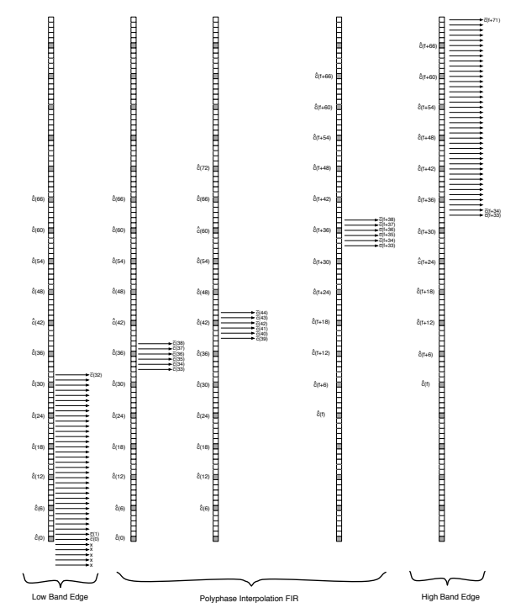

Figure 6‑2 Wiener interpolation/smoothening with 6-PRB estimator in practice

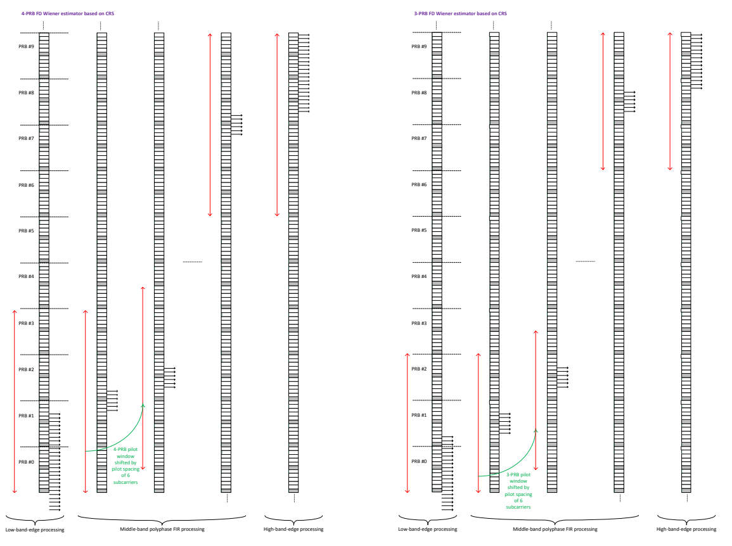

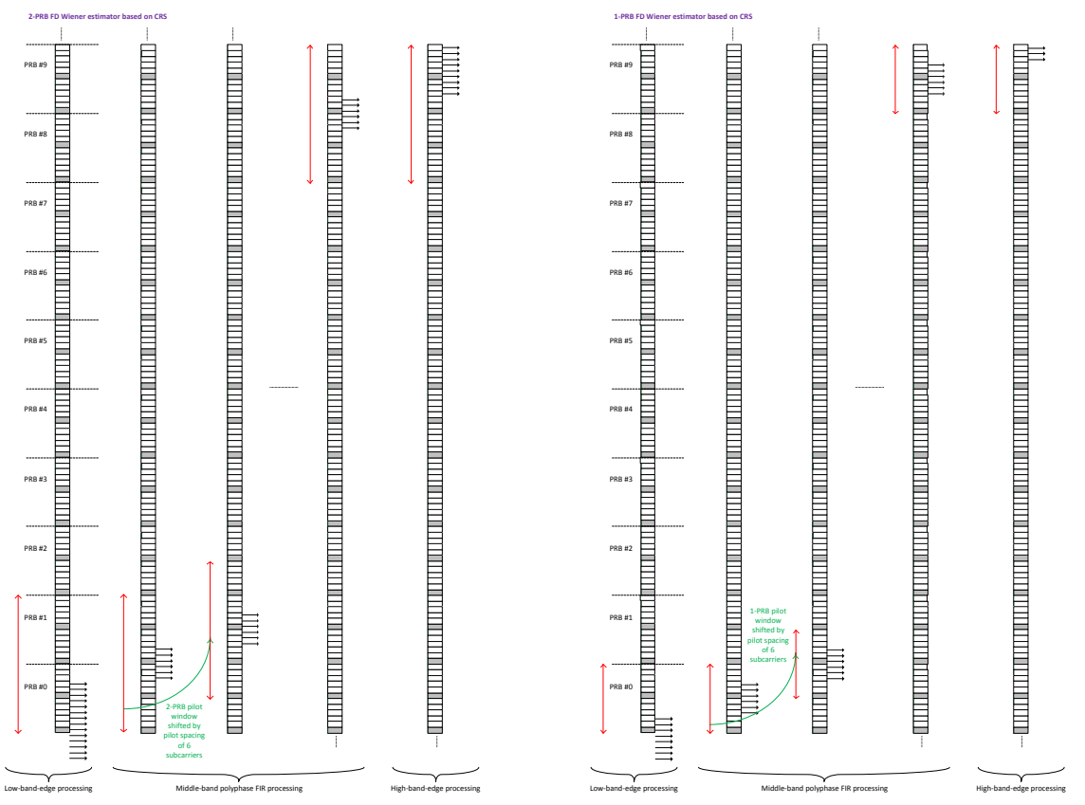

Figure 6‑3 Wiener interpolation/smoothening with 4-PRB (top-left), 3-PRB (top-right), 2-PRB (bottom-left), 1-PRB (bottom-right) estimator in practice

#### Calculation of 6-PRB Wiener Interpolator Coefficients for LTE CSI-RS

Here, we consider calculation of filter coefficients for a 6-PRB Wiener interpolator. In this case, the measurements are given by a 6-by-1 vector

The vector of length 83 (72+11) to be estimated is

The 6-by-6 autocorrelation and 83-by-6 cross-correlation matrices are now given by

and

respectively.

#### Derivation of TD Wiener Filter

If we utilize only frequency domain measurements from the channel transfer function and assume uncorrelated scattering the process , the frequency correlation function is given by

which is Fourier transform of the Doppler spectrum. For the Jakes spectrum (which is the used model for the fast fading in wireless communications) it is given by

for mobile station velocity of is order Bessel function of the first kind. The autocorrelation matrix has the elements

and the cross correlation matrix elements

##### Generic TD Wiener parameterization in Korak

|  |  |  |  |
| --- | --- | --- | --- |
| **Parameter** | **Description** | **Value** | **Default value** |
| tdCorrFcn | There are two practical approaches, referred to as the ‘tdCorrMdl-1’, ‘tdCorrMdl-2’. (Note 1) | string | - |
| flex-config-dsg-prms-1 | vector of indices, which corresponds to RS (OFDM) symbol positions within a subframe/slot in time direction. | integer |  |
| flex-config-dsg-prms-2 | number-of-symbols-per-subframe, i.e, 14 | integer | - |
| tdInterpolationType | no-interpolation: No TD interpolator. Sample and Hold.  linear: Linear interpolation in time, with extrapolation.  wiener-interpolation: TD generalized wiener estimation. (Default option)  linear-and-hold: Linear interpolation in time between measurements, hold the last measurement value until end of the slot  phase-amplitude: TD interpolation in polar coordinates | string | - |
| design-speed | Design speed of the filter. Either set as kph, or ‘ue-speed’, or ‘estimate-speed’. | integer | - |

(Note 1) Time correlation models:

* 1. The element ***<tdCorrMdl-1>***
  2. The element ***<tdCorrMdl-2>***

Similar approach as case *tdCorrMdl-1* but with design SNR offset and predetermined SNR gain due to frequency domain wiener filter.

### Ideal Estimator

# Measurements

|  |  |
| --- | --- |
| Author | Panayiotis Papadimitriou, Mikko Maenpaa |
| Related functions | GeneralizedRRMMeasurement.m, RRMmeasurementData.m |

According to [36214, Section 5.1], the **Reference signal received power (RSRP)**, is defined as the linear average over the power contributions1 (in [W]) of the resource elements2 that carry cell-specific reference signals within the considered measurement frequency bandwidth. For RSRP determination the cell-specific reference signals R0 according to 38211 shall be used. If the UE can reliably detect that R1 is available it may use R1 in addition to R0 to determine RSRP. The reference point for the RSRP shall be the antenna connector of the UE. If receiver diversity is in use by the UE, the reported value shall not be lower than the corresponding RSRP of any of the individual diversity branches.

Also from [36214, Section 5.1], the **Reference Signal Received Quality (RSRQ)** is defined as the ratio N×RSRP/(E-UTRA carrier RSSI), where N is the number of RB’s of the E-UTRA carrier RSSI measurement bandwidth. The measurements in the numerator and denominator shall be made over the same set of resource blocks.

E-UTRA Carrier **Received Signal Strength Indicator (RSSI)**, comprises the linear average of the total received power (in [W]) observed only in OFDM symbols containing reference symbols for antenna port 0, in the measurement bandwidth, over N number of resource blocks by the UE from all sources, including co-channel serving and non-serving cells, adjacent channel interference, thermal noise etc. If higher-layer signalling indicates certain subframes for performing RSRQ measurements, then RSSI is measured over all OFDM symbols in the indicated subframes. The reference point for the RSRQ shall be the antenna connector of the UE. If receiver diversity is in use by the UE, the reported value shall not be lower than the corresponding RSRQ of any of the individual diversity branches.

1The power per resource element is determined from the energy received during the useful part of the symbol, excluding the CP. 2The number of resource elements within the considered measurement frequency bandwidth and within the measurement period that are used by the UE to determine RSRP is left up to the UE implementation with the limitation that corresponding measurement accuracy requirements have to be fulfilled.

### RSRP calculation

Let's assume that the cyclic prefix is longer than the channel delay spread and therefore the received signal at a single CRS (antenna port 0) position has as following:

(1)

The RSRP by definition is the average of H over time and frequency. However due to the existence of the noise term, the averaging and extraction of H is not trivial. If we multiply with the conjugate of the RS RE we get the channel estimate in that RE:

where , and .

One approach would be to average over a time-frequency region (e.g. 1 PRB) of the aforementioned equation to average out the noise terms, and then compute the power, which will be some noisy estimation of. However, this approach is not going to remove completely the noise (i.e. converge), since when we take the power , the variance of the noise terms will kick in.

Therefore, we need some algorithm that won't yield quadratic noise terms when we take the power. Towards this direction, we found the following techniques that achieves the removal of noise quadratic terms:

Let two “neighbors” ' and ' (closest two RR REs in time or frequency) having almost identical channel H. Then the quantity (where the averaging is taken over many samples, e.g. 200ms) below gives the RSRP:

(2)

So (2) becomes:

Since and .

Neighboring RS REs can be in time or frequency direction.

RSRP averaging over the samples in Korak depends on the algorithm type:

#### Algorithm type 1 (coherent combining of the samples):

In one TTI, channel estimate is calculated for all REs that carry the RS within the considered measurement frequency bandwidth. Then is calculated using neighboring RS REs either in time or frequency direction. One sample corresponds to a specific number of values, depending on the total number of RS REs, calculated in one TTI. Finally, measurement sampling rate determines the number of samples used for averaging. At measurement period, RSRP is calculated as in equation (2), hence averaged over all values.

#### Algorithm type 2 (non-coherent combining of the samples):

Calculation of values within one TTI is the same as in algorithm type 1. Then RSRP estimate is calculated for each sample, based on the measurement sampling rate:

For every sample, is calculated. Then at measurement period, RSPS is calculated as an average of samples:

#### Algorithm type 3

This algorithm is used in WCDMA. Let 2 “neighbours” Y 0 1 and Y 0 2 having almost identical channel H. Then the quantity (where the averaging is taken over many samples, e.g. **200ms**)

Since and .

#### Algorithm type 4

To do

### RSSI calculation

For the RSSI calculation, one approach is to use: , as:

since as

Also, since we have the terms and calculated already for the RSRP, we could have:

since and we assume that

The RSSI algorithm should be scaled accordingly to take into account sum over *N* resource blocks, therefore in this sense the first approach of seems more straightforward. In this case , i.e. RSSI calculation, will become:

where the summation is over *N* = 6 PRBs (this number *N* not to be confused with the noise variable *N*)

### RSRQ calculation

According to RSRQ definition given in Section I, we have that:

where *RSSI* is only E-UTRA RSSI and as said above *N* = 6 (PRBs).

### SNR calculation

Having calculated the various RRM parameters the SNR calculation (to be used outside RRM, in modem purposes as needed) is straightforward:

### Interference measurements methods

|  |  |
| --- | --- |
| Author | Hesham Elgendi |
| Related functions |  |

#### Non-zero power CSI based

#### Channel state information interference measurements (IM)

### Generic parameterization in Korak

|  |  |  |  |
| --- | --- | --- | --- |
| **Parameter** | **Description** | **Value** | **Default value** |
| RSSI-meas-symbols | OFDM symbols from which RSSI and RSRQ are measured. If none is specified, it uses all the OFDM symbols that have the reference signal. | integer | RSSI-meas-symbols |
| rs-to-use | Reference signal to measure. | string | nr-pbch-dmrs | nr-pdsch-dmrs | nr-csirs | nr-sss | nr-srs |
| bts-id | Basestation ID, defined in the xml basestation element, from where the reference signal is transmitted | integer | - |
| sampling-rate-sfs | Rate in subframes when the defined reference signal is measured/sampled. Note: This number has to be multiple of the reference signal's periodicity | integer | - |
| measurement-period-sfs | Period in subframes when the RRM measurements are performed. Note: This number has to be multiple of sampling-rate-sfs | integer | - |
| measurement-BW-RBs | Bandwidth in PRBs from where the RS REs are taken for the measurements. Note: This only applies to RSSI and RSRQ | integer | - |
| algorithm-type | Type 1 is more accurate, but somewhat more complex. Use it as a default. Exact definition available in previous sections. | integer | 1 | 2| 3 |
| nbr-RS-occasions-per-sample | At sampling rate instance, how many RS occasions are used for the sample. A single RS occasion means a single slot/subframe carrying the RS. | integer | - |
| neighbouring-RS-REs-in | Default is *frequency.* Whether the algorithm uses RS RE pairs in time of frequency direction. The algorithm assumes that the channel is the same between two neighboring RS REs. Select direction based on channel frequency selectivity and coherence time and the actual RE pattern used so that the assumption is valid. | string | frequency| time |
| rs-tx-ports-to-measure | In case of multiple RS Tx antenna ports, select the ports used for measurements. | integer | - |

# Channel coding

## LDPC

|  |  |
| --- | --- |
| Author | Toni Levanen, Elena Peralta |
| Related functions | NRLdpcCode.m, NRLdpcCodeParameters… |

A simplified encoder and decoder processing model is given in Figure 7.1.

The LDPC decoder is used for all data channels. Decode code block based on selected algorithm:

* Type 1: original implementation accurate message-passing algorithm [12]
* Type 2: original implementation accurate message-passing algorithm
* Type 3: Faster implementation of accurate message-passing algorithm
* Type 4: min-sum approximation, Faster than 3, some performance degradation (FFS) [13]
* Type 5: min-sum approximation, Faster than 4, some performance degradation (FFS)
* Type 6: Faster implementation of accurate message-passing algorithm, faster than 3, performance (FFS)

The so-called Min-Sum algorithm is a generalization of “Viterbi algorithm” and the so-called Sum-Product algorithm is a generalization of “Forward and backward algorithm”. Summary description of both algorithms is as follows based on [14]:

### Min-sum algorithm

Local cost function (γs, γE)

Intermediate cost function (µs,E, µE,s)

Final cost function (µs, µE)

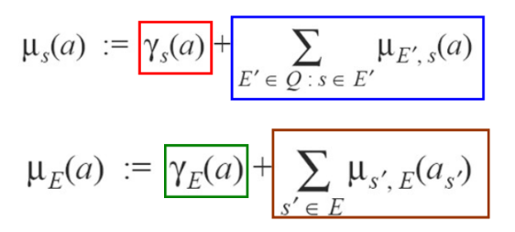

Global function (G(x))

Example case weight 3 [14]:

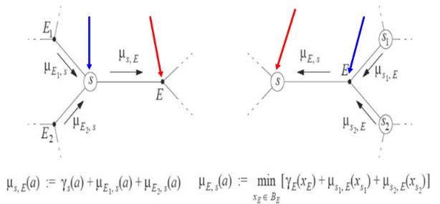

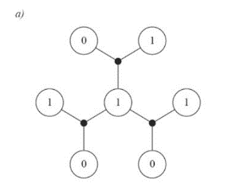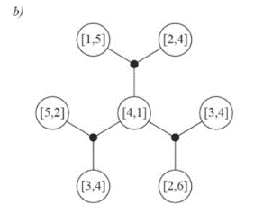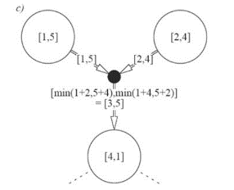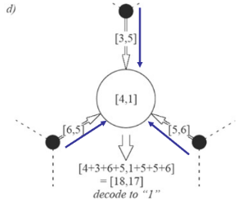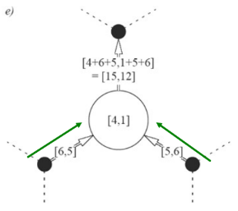

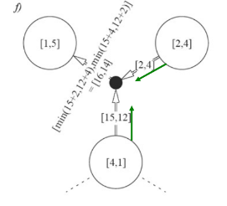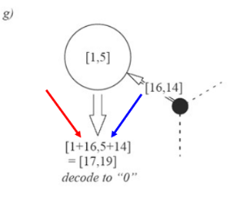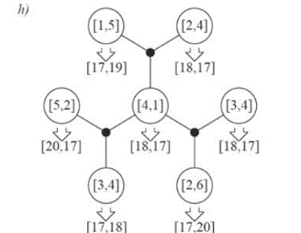

Only interested in the difference between “1” cost and the “0” cost.

### Sum-product algorithm

Global function (G(x))

Local check cost (γE)

with equality if and only if

Local site cost (γE´s)

if and only if

Global cost of a configuration x is strictly positive if x is valid

Intermediate cost function (µs,E, µE,s)

Final cost function (µs, µE)

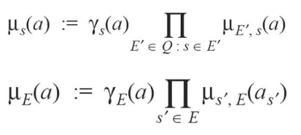

Example case weight 3 [14]:

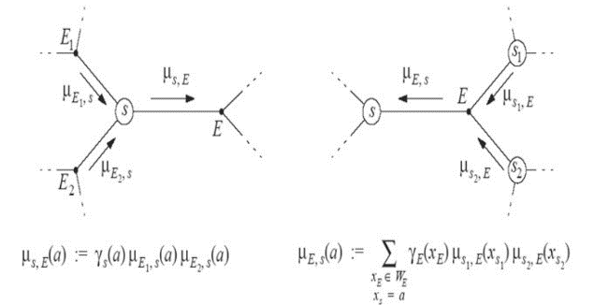

## Turbo

## Polar Codes

|  |  |
| --- | --- |
| Author | Pasi Kinunnen |
| Related functions |  |

To do

# Waveforms

|  |  |
| --- | --- |
| Author | Toni Levanen, Ismael Peruga |
| Related functions | … |

## Processing

### FD and TD transform block

### Filtering block

### PAPR reduction block

### Preprocessing block

### Spectral Shaping block

### Time Domain processing block

### Windowing block

## NR candidates waveforms

### CP-OFDM

### DFT-s-OFDM

### FCFB-F-OFDM

### UFMC

### WinSic-F-OFDM

### WOLA

### ZT-DFT-s-OFDM

# Channel models

There are multiple channel models implemented in Korak. The channel model and the mobile speed can both be changed from the parameter file. For each OFDM symbol, there are usually 4 channel samples (can be adjusted). This way it is possible to model the effects of mobile movement to the received signal, as the channel is not fixed during the transmission of one OFDM symbol. The radio channel effect is normally applied to the signal by using the Lsc-library functions, because the channel is handled as an object that was initialized at the beginning of the simulation. Similarly, the channel is regenerated by calling the member function of the channel object at every fast fading drop. Additive white Gaussian noise is added to the signal in order to achieve the required SNR. In NR, there is a possibility to use the pass-lsc flag allows to skip lsc libraries and generates the channel based on Matlab toolbox libraries.

## 3GPP Tapped Delay Line Models

|  |  |
| --- | --- |
| Author |  |
| Related functions |  |

To do

## 3GPP Clustered Delay Line Models

|  |  |
| --- | --- |
| Author | Pasi Kinunnen |
| Related functions |  |

|  |  |  |  |
| --- | --- | --- | --- |
| **Model Parameter** | **Description** | **Value** | **Default value** |
| mobility-modeled |  |  |  |
| LosDoppler |  |  |  |
| basestation-antenna-bearing-angle |  |  |  |
| basestation-antenna-slant-angle |  |  |  |
| basestation-antenna-tilt-angle |  |  |  |
| basestation-line-of-sight-azimuth-angle |  |  |  |
| basestation-line-of-sight-elevation-angle |  |  |  |
| basestation-panel-shift |  |  |  |
| basestation-positions |  |  |  |
| beamAngleSelectionMethod |  |  |  |
| bs-ms-desired-azimuth-spread |  |  |  |
| bs-ms-desired-elevation-spread |  |  |  |
| channel-desired-delay-spread-ns |  |  |  |
| channel-desired-k-factor-db |  |  |  |
| idealChannel |  |  |  |
| max-link-delay-ns |  |  |  |
| mobile-station-antenna-bearing-angle |  |  |  |
| mobile-station-antenna-slant-angle |  |  |  |
| mobile-station-antenna-tilt-angle |  |  |  |
| mobile-station-line-of-sight-azimuth-angle |  |  |  |
| mobile-station-line-of-sight-elevation-angle |  |  |  |
| mobilestation-position |  |  |  |
| normMethod |  |  |  |
| num-basestations |  |  |  |
| random-mobile-station-antenna-bearing-angle |  |  |  |
| scenario |  |  |  |
| type |  |  |  |

|  |  |  |  |
| --- | --- | --- | --- |
| Antenna parameters  1. basestation  2. mobile station | Description | Value | Default value |
| antenna-element-radiation-pattern-type |  |  |  |
| delta-horizontal |  |  |  |
| delta-panel-horizontal |  |  |  |
| delta-panel-vertical |  |  |  |
| delta-vertical |  |  |  |
| num-columns |  |  |  |
| num-elements-per-column-per-polarization |  |  |  |
| num-panels-horizontal |  |  |  |
| num-panels-vertical |  |  |  |
| num-polarization |  |  |  |
| panel-type |  |  |  |

## Matlab TDL model

## Single Link

To do

## Extended link (System Simulator w/ LL Simulation)

Extended link allows accurate modelling of inter cell interference, where the interfering signal is individually generated from each base station in the network for downlink (or from each UE in uplink). All UEs are connected to a single cell. The interfering signal is explicitly modelled, where the pathloss for the interferer is set based on the *Dominant Interferer Ratio* (DIR) parameter. Generally:

### Interfering modelling

|  |  |
| --- | --- |
| Author | Mikko Maenpaa |
| Related functions | SINRRangeSimStats.m |

Based on [5], interference-to-noise-Ratio (INR) profiles have been evaluated and agreed in 3GPP work by several companies in order to simulate with the same interference settings. INR profiles can be mapped to the so-called DIP profiles, which are used in the simulator. INR profile defines the signal-to-noise ratio of the explicitly modelled interferer(s) whereas DIP profile defines the power ratio(s) between the explicitly modelled interferer(s) and the overall interference plus noise power. In the link simulator, first the baseband time-domain waveforms of the serving base station, dominant interferer and weaker interferer are generated. Then the propagation of each signal through the channel is modelled and interfering signals are scaled based on the interference model before adding them to the overall signal. Finally, AWGN is added to the overall signal based on the desired SINR. This is illustrated in Figure 10‑1 and Figure 10‑2, where INR3 profile is used to have example values. These values are derived in the following.

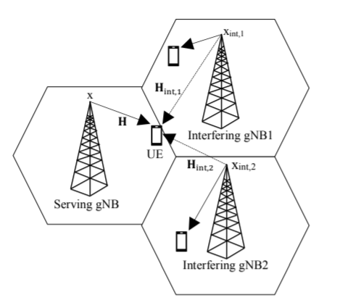

Figure 10‑1 Interference model consists of one serving cell and two interfering cells. Here x, xint,1 and xint,2 correspond to the transmitted symbols from serving and interfering gNBs respectively (dominant and weaker), and H, Hint,1 and Hint,2 correspond to the channel responses of the received signals for each relevant subcarrier index [15]

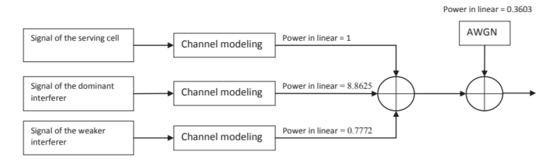

Figure 10‑2 Illustration of interference modeling. Interfering signals are scaled based on the interference model before adding them to the overall signal. AWGN is then added to the overall signal based on the desired SINR [5]

The INR3 profile, which corresponds to one strong interferer (dominant interferer) and one weaker interferer, is defined as follows with desired SINR of -10dB:

In particular, INR3 profile corresponds to relative powers of [13.91, 3.34] dB, where the first value is for the dominant interferer and the second for the weaker interferer. INR3 profile corresponds to DIP profile of [-0.524416, -11.09441] dB. In Korak, DIP values can be calculated with the function *map_inr2dip.m* for a given INR.

#### Generic parameterization

|  |  |  |  |
| --- | --- | --- | --- |
| **Model Parameter** | **Description** | **Value** | **Default value** |
| interfering-basestation-id-set | IDs of the interfering cells | Integer | [101 102…]  ID=100 for serving cell |
| relative-power-of-interferers-db | DIP profile values | Integer | - |

#### Asynchronous time model

The time offset can be defined in the XML per each gNB.

### RIM modelling

|  |  |
| --- | --- |
| Author | Elena Peralta, Mikko Maenpaa |
| Related functions | SINRRangeSimStats.m |

The remote interference problem stemming from the atmospheric ducting phenomena has been investigated in 3GPP 5G NR technical reports and it is illustrated in Figure 10‑3 and Figure 10‑4. In this case, the fundamental task of NR-RIM is to detect when the remote interference occurs, to identify the group of interfering gNBs, and finally to measure the propagation delays between the aggressor and victim gNB or groups of gNBs.

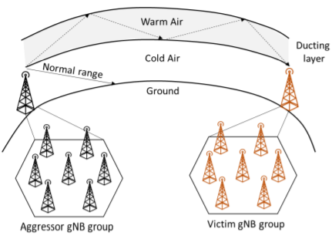

Figure 10‑3 Illustration of the remote interference problem stemming from the atmospheric ducting phenomenon [10]

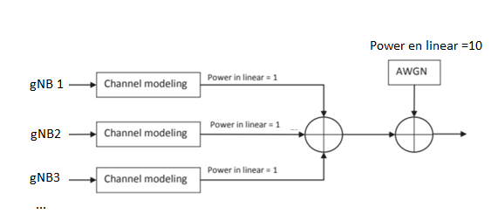

Figure 10‑4 Illustration of the rim modelling

Following similar approach as in previous section with desired SINR of -10dB and 4 transmitting gNBs, there are two possible RIM calculation methods:

Method 1:

Method 2:

#### Generic parameterization

|  |  |  |  |
| --- | --- | --- | --- |
| **Model Parameter** | **Description** | **Value** | **Default value** |
| rim-basestation-id-set | IDs of all transmitting gNBs | Integer | [100 101 102…] |
| relative-power-of-rim-bts-db | Note: all gNBs are assumed to transmit with the same power | Integer | [0 0 …] |
| total-number-RS | Total number of transmitting gNBs (needed for async time model) | Integer | - |
| calculation-method | RIM calculation method | Integer | 1 | 2 |

#### Asynchronous time model

The time offset can be defined in the XML per each gNB. There are several approaches for RIM studies defined in LSC libraries:

1. ***<time-offset-sec>*** equals to TO: time offset defined in XML per each bts
2. ***<max-range-offset>*** equals to TO: random time offset calculated per TTI in the range [0, TO] per each bts
3. ***<uniform-range-offset>*** equals to TO: uniform delay randomly selected from set of uniform delays per each bts. Discrete values chosen within 0:step:TO for per each bts.
4. ***<uniform-range-offset-set-randomly-selected-per-TTI>:*** uniform delay randomly selected from set of uniform delays per TTI and per each bts.

# Receiver

## Receiver front end

A simplified baseband receiver model is given in Figure 11.0.

Figure 11.0 Simplified Baseband Receiver Model based on NR release 15 implementation

At the receiver, the raw received signal is filtered, and the cyclic prefix is removed. The signal is converted back to parallel streams using a FFT operation with the FFT size matched to the used bandwidth. The channel impulse response is estimated at the receiver or alternatively the estimate can be ideal, meaning that the values are copied directly form the channel model. With genuine channel estimation, the reference symbols sent over the channel are used when calculating the estimate. The data symbols in the time-frequency grid must be de-mapped back to a separate stream, because the grid is divided into multiple physical channels and is not purely dedicated to a single codeword transmission. The detector used depends on the transmission scheme and it is specified in the simulation parameters. In general, the detector uses the channel estimate and the received symbol values to calculate an array of soft bits. These values are fed to the channel decoder, which can also combine soft bits from possible earlier transmissions in order to get an array of decoded bits. These decoded bits include a CRC-checksum that can be used to calculate, whether the codeword was successfully decoded.

### RF impairments

|  |  |
| --- | --- |
| Author | Panayiotis Papadimitrou, Toni Levanen |
| Related functions |  |

The RF impairments modelled in the receiver, are those of phase noise and IQ imbalance [16]. On one hand, the **phase nois**e (PN) is introduced by the analog mixer stage due to the local oscillator (LO) being sensitive to noise, and effects both the amplitude and frequency of the signal. On the other hand, IQ imbalance arises in the front-end of the receiver, when the I and Q branches are not exactly orthogonal and having amplitude mismatch. **IQ imbalance** is generally characterized by two parameters: the amplitude mismatch (gain imbalance), and the phase imbalance (phase orthogonality mismatch).

The received signal power varies over a wide dynamic range due to the wireless channel propagation and the various possible interferers. Hence, it is of essential importance to dynamically adjust the power of the incoming signal to avoid saturation at the analog-to-digital converter (ADC). This is the task of the **AGC unit**.

### Time offset estimation/compensation

|  |  |
| --- | --- |
| Author | Panayiotis Papadimitrou , Elena Peralta, Jorge Morte |
| Related functions | LTE related classes in user_equipment\receiver\timing  NR related classes in cmwave\algoritms\user_equipment\receiver\timing |

Time offset correlation relates to the multipath delay spread of the channel, as well any propagation delay give rise to timing offset between the transmitter and the receiver [16]. The propagation delay is compensated by the timing advance (TA) concept, however the delay spread of the channel has to be compensated at the receiver. The correct timing in OFDM-based systems is of high importance for the performance of the receiver.

In the first implementation for LTE systems, we perform the estimation in the time-domain, by correlating OFDM symbols carrying CRS, within a subframe. Averaging over two subframes is performed, and the estimator is triggered every 5 ms. See section 15 for further details.

Generalization of this methodology is implemented in NR, where there are three possible time offset estimation (TOE) algorithms implemented: 1) ‘lte-legacy’ based on LTE implementation, 2) ‘correlation’ based on LTE implementation and adapted for demodulation and channel estimation reference signals in NR, 3) ‘cir-based’ implemented for NR as described in section 2 and 3. In this case, the main idea is to estimate the raw pilots and perform the processing for the time offset estimation in the frequency domain. Therefore, in the receiver class “frequency domain time offset estimation” is assumed, and “time domain time offset estimation” should be further develop. The algorithm is rather generic, so the extension to any reference signal is feasible. At the moment, cmwave DMRS, REL15 DMRS, PBCH DMRS and PRACH reference signals are supported. Related algorithms can be found in sections x x x, respectively.

### Frequency offset estimation/compensation

|  |  |
| --- | --- |
| Author | Panayiotis Papadimitrou , Toni Levanen |
| Related functions |  |

The frequency offset arises from the frequency uncertainties in both the eNB transmitter and UE receiver [16]. According to the 3GPP specifications, the minimum requirement for the frequency error in the eNB is ± 0.05ppm, which for a carrier frequency of fc= 2GHz, translates to a frequency error of ± 100Hz. If we assume also a frequency error of ± 0.1ppm in the UE receiver (which equals to ± 200Hz for fc= 2GHz), then we have accumulated uncertainty of ±300Hz. (See TS 38101).

In addition, for a moving UE, the Doppler shift is getting into the picture. This is the source of the frequency offset in the simulations (as well the estimation errors of the frequency estimator). In the first implementation for LTE systems , the frequency offset is estimated simply by averaging the phase difference of the correlation peaks (at the estimated timing offset) resulted from the time offset estimation. In NR… --complete—

### Cyclic Prefix Removal

|  |  |
| --- | --- |
| Author | Heikki Berg |
| Related functions |  |

In an OFDM symbol the cyclic prefix (CP) is a repeat of the end of the symbol at the beginning, thus of the NFFT samples NCP last samples are copied to the beginning of the symbol. The purpose of CP is to allow “echoes” of the last sample of the previous OFDM symbol die out before the start of the next OFDM symbol. The “echoes” are due to the multipath propagation of the transmitted signal. In addition CP preserves cyclic convolution properties of transmitted signal with channel impulse response and also provides robustness against timing errors.

Start of the subframe is estimated by the receiver from synchronization signals embedded into the transmitted OFDM symbols. The A/D conversion of the RF signal is started ideally so, that first sample received for signal processing is exactly from the beginning of the cyclic prefix of the first OFDM symbol. Figure 11‑1 illustrates the selection of samples from each of the OFDM symbols for FFT size NFFT = 2048. Exactly NFFT samples are selected of each OFDM symbol for FFT operation. Symbol timing dt for the subframe *t* is an estimate for the correct timing.

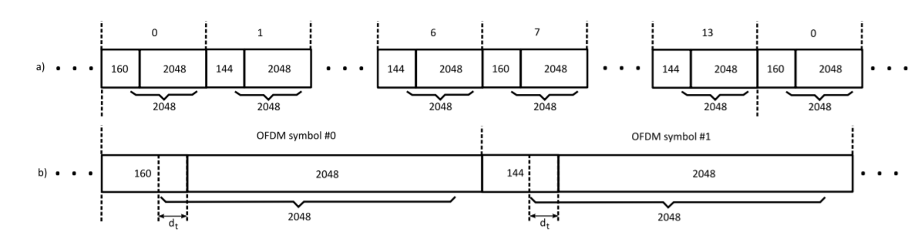

Figure 11‑1 Selection of samples for cyclic prefix removal: a) Complete subframe of 14 symbols; b) Expanded view of first two symbols of the subframe

### Frequency hopping

|  |  |
| --- | --- |
| Author | Pasi Kinnunen |

To do

### VRB to PRB mapping

|  |  |
| --- | --- |
| Author | Jorge Morte |

To do

### Fast Fourier Transform

Fast fourier transform algorithm implements discrete fourier transform (DFT) to the time domain signal. The transform is done to the signal from each receiver antenna port p separately.

## Detector MMSE

|  |  |
| --- | --- |
| Author | Panayotis Papadimitrou, Tero Ihalainen |
| Related functions | Detector_MMSE.m, Detector_MMSE_CmWave.m |

Model at the receiver:

where **y** is the received signal vector of size M (M the number of receive antennas), (·) T is the transpose operator, **x** is the transmitted signal vector of size N (N the number of transmit antennas), **Q** is the interference vector (any interference terms received) of size M, **n** is the additive white gaussian noise and **H** is the MIMO channel matrix of size M × N.

In the MMSE detection, the principle used is to find a weighting matrix **W** of size M × N, such that the cost function of mean square error between the weighted received and the transmitted signal is minimized:

where is the hermitian (i.e. conjugate-transpose) operator.

After few calculations, the equation can be shown to yield to the Wiener-Hopf equation [12]:

where

in general is measured at the receiver, and

so, the final equation becomes:

and the MMSE detected symbol is

If we take the mean, we will see that this detector is biased, i.e.

with the bias term, obviously, given by:

where

Therefore the MMSE detected symbol equivalently becomes:

where

and **o** is the residual-interference (cross-interference) terms from the MMSE detection. If we assume andwe have that,

### Implementation aspects

The MMSE solution (), involves the inversion of an M × M matrix. Since mostly M ≥ N, it makes sense to transform the MMSE solution such that it involves the inversion of a lower size matrix N × N. This is possible through the matrix inversion lemma, where it can be shown, [13] that

and therefore,

where

In SIMO (1 × 2 ) cases, one should use the solution of , since the condition number of in becomes huge (i.e. the is close to singular). In addition when there is interference and large number of receive antennas, the solution of should be preferred in terms of complexity.

## Detector MMSE interference suppression prior to TxD detection

|  |  |
| --- | --- |
| Author | Panayiotis Papadimitrou , Tero Ihalainen |

In this section we show how to apply the MMSE principle to suppress the interference on the received signal prior to Transmit-Diversity Detection.

### MMSE across Rx Antennas (sub-optimum receiver)

Let the model be as:

where . Then form:

where is the hermitian (i.e. conjugate-transpose) operator.

After few calculations, the equation can be shown to yield to the Wiener-Hopf equation [12]:

where

in general is measured at the receiver, and

so, the final equation becomes:

which is the MMSE solution of the Detector MMSE (see previous section) times the . So, the MMSE interference suppressed received signal is

A straightforward approach is to then, to directly apply the SFBC detector (see coming sections) to the . Note that the same will have to be applied in subcarriers 2i and 2i + 1, due to the SFBC decoding (in SFBC decoding we assume consecutive subcarriers have experienced the same channel, so we could safely assume they have experienced same interference). So e.g. calculate for the subcarrier i, and apply the same to the subcarrier 2i+1. Note that in the calculation we can utilize the average accross neighbour pairs of subcarriers for both the **H** and the .

However the direct application of the SFBC detector to although it showed giving huge gains (>50%) under single interferer, when the noise became more coloured (two interferers) the gain diminished to the order of about 10%. This has to do with the fact that the calculated channel estimates, and noise/interference estimates were calculated prior the MMSE filtering and therefore they shouldn’t be used as such for the subsequent SFBC detector. Rather, the effective (including the filtering effect) channel estimates and noise/interference estimates should be used in the SFBC detector.

Let’s try to understand this, by expanding further

or equivalently

where **.**

**So the SFBC detector (see coming sections) should be applied now to , by utilizing the effective channel estimates and noise estimates , , instead of the original ones.**

It should be noted that the effective noise variance to be utilized in the decoder is also changed according to the following autocorrelation

from where we extract the effective noise variance as:

An alternative -slightly lower complexity- for the effective noise variance is derived if we apply the approximation ( the wideband noise variance averaged accross Rx antennas):

### Full MMSE solution for 2x2 SFBC

Let the channel model:

where **r** is the received signal vector, and **y** is the transmitted SFBC-coded signal vector to be defined as following for one receive antenna *m* containing two consecutive subcarriers *i* and *i + 1*:

**---To do---**

## Maximal Ratio Combiner (MRC) and Transmit Diversity Detection

|  |  |
| --- | --- |
| Author | Mikko Maenpaa |

In maximum ratio combining, interference is considered as white noise and thus only knowledge about the own effective channel is required [5]:

Assuming the cyclic prefix length is greater or equal to the channel delay spread, we end up with the following model at the receiver:

where is the received signal vector of size M (M the number of receive antennas is the transpose operator, is the transmitted signal vector of size N (N the number of transmit antennas) assuming (assuming ), **Q** is the (uncorrelated to the transmitted signal, ) interference vector (any interference terms received) of size M, is the additive white gaussian noise of power spectral density and **H** is the MIMO channel matrix of size M × N.

The MRC detector is applied when we know we have one only transmit antenna in the eNB, N = 1. The number of transmit antennas is detected in the PBCH detection (see section). So assuming we have also two UE receive antennas M = 2 , the channel model of becomes:

Then the MRC combiner is:

where A depends on the soft demodulator used. In the Korak implementation, it is set to:

is then fed to the soft demodulator [check demodulation] to yield the soft bits.

Combining further (just for demonstration purposes) equations, we get:

from where we see that the MRC combiner achieves diversity of order 2 (due to the multiplicative factor of ).

In the case of fully orthogonal effective channel, MRC is able to maximize the SNR for each data stream separately, which results in the SNR-optimal total solution. However, in practice the effective channel is not fully orthogonal due to imperfect precoding and channel estimation error. Consequently, the effective channel causes intra-stream interference and hence MRC is not able to optimize the overall SINR.

## Linear Minimum Mean Square Error (LMMSE)

Linear Minimum Mean Squared Error combining takes into account multi-stream interference. In addition, LMMSE can take into account spatial properties of received interference plus noise. LMMSE is able to minimize this multi-stream interference and thus LMMSE solution is more optimal solution than MRC in the case of non-orthogonal effective channel [7]. The receive filter for LMMSE in general form is solved in the following.

By assuming the following linear signal model

the LMMSE estimator can be written as

where namely the covariance of receive signal , and , namely the covariance of the received signal and the original data symbol vector . has been solved already section 5 and is of the form:

where denotes the interference plus noise covariance matrix. Next the can be solved as follows

Finally the receive filter for LMMSE combiner can be written as

The capability of LMMSE receiver to suppress inter-cell interference depends heavily on the accuracy of interference plus noise covariance estimation. In section 7.1.5, three different interference plus noise covariance estimation methods were introduced. These three methods do the interference plus noise covariance estimation with different degrees of precision. The precision depends on the assumptions of the interference behavior, the complexity of the estimation algorithm and the available information about channels of interfering links. The more precise the interference plus noise covariance is, the better the interference can be suppressed, which in turn improves the post-processing SINR of LMMSE receiver, or in other words, results in better performing LMMSE receiver.

## Interference aware receivers

|  |  |
| --- | --- |
| Author | Mikko Maenpaa, Tero Ihalainen, Elena Peralta |

The extended single-link-with-interference network model can model intercell interference from a chosen number of interferer eNBs.

Three refence signal based covariance estimators for MMSE-IRC were implemented. In this case, both CSI-RS and DM-RS based estimators are available. One estimator utilizes a pair of neighbouring pilots to differentially construct samples for the noise covariance estimation, where the estimation can be carried out independently of channel estimation. On the other hand, another approach is to utilize the reference signal REs within a PRB constructing residual interference samples by substracting the desired signal contribution from the received samples based on the effective channel estimates. Finally, an enhanced estimation method assuming knowledge of interfering links was implemented. See setion 4.1.2.2 Covariance Matrix Estimation for further details.

### NAICS receivers

In general, the system model consists of one serving cell and two interfering cells. Simplified NAICS system model is illustrated in Figure 11‑2 from [5].

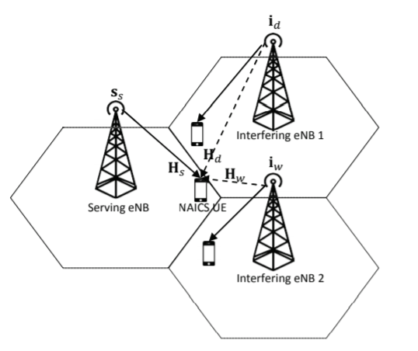

Figure 11‑2 Simplified illustration of system model in NAICS. Signals s_s, i_d, and i_w are intended for served UEs in serving cell, dominant interfering cell and weaker interfering cell, respectively. Channels Hs, Hd, and Hw are between the serving basestation and NAICS UE, dominant interfering basestation and NAICS UE and weaker interfering basestation and NAICS UE, respectively. [5]

The UE is assumed to be in the cell edge and therefore, the following advanced receivers are considered: interference cancelation, network assisted covariance estimation and non-linears receivers. Due to the complexity that the signalling can cause to the network, we can include blind detectors, therefore, to blindly estimate parameters of interfering cells without or with low network assistance. Finally, many receiver functions require knowledge about the interference plus noise power to perform optimally, which can be estimated by using reference signals as they are known to the receiver in advance, e.g differential estimation method.

## Transmit diversity detector (Space-Frequency Block Code (SFBC))

Transmit Diversity was implanted in LTE with 2 or 4 eNB transmit antennas. With 2 transmit antennas (receiver should have at least 2 antennas) the transmit diversity scheme is called Space-Frequency Block Code (SFBC), and with 4 antennas is called Space-Frequency Block Code with Frequency Switched Transmit Diversity (4x2 SFBC-FSTD).

### 2x2 SFBC Detector

## Interference Rejection Combining (IRC) Receiver

### Background

From NAICS system perspective [5], there are two different scenarios where CRS interference cancellation (CRS-IC) can be used to improve overall system performance, namely colliding and non-colliding CRS scenarios. In the case of colliding CRS, at least CRS transmitted from the dominant interfering eNB collides with CRS of the serving eNB. In other words, interfering and serving eNBs transmit CRS on the same time-frequency positions, that is, on the same resource elements. Whereas in the case of non-colliding CRS, at least CRS transmitted from the dominant interfering eNB collides with PDSCH of the serving eNB and consequently CRS of the interfering eNB distorts some of the PDSCH resource elements of the serving eNB. In the case of colliding CRS, CRS-IC can be used to improve the quality of channel estimates by cleaning the interfering CRS from the desired CRS. Whereas in the case of non-colliding CRS, CRS-IC can be used to clean those PDSCH REs, which contains CRS from the interfering eNB and consequently it can improve the performance of detection and demodulation of PDSCH. Note that CRS-IC can also be used in the same way to improve the interfering links’ channel estimation and PDSCH demodulation performance in the case of colliding CRS and non-colliding CRS, respectively.

### Implementation

The main principle of the *Interference Rejection Combining* (IRC) UE receiver in Korak is exploit the spatial correlation due to interferer(s) in the RX antennas to suppress intercell interference in addition to combating channel fading through spatial diversity.

The IRC receiver implementation in Korak utilizes mainly a differential noise/interference covariance estimation. The NRx x NRx raw covariance estimates are calculated differentially from a pair of NRx-length signal vectors which are constructed from received samples at different Rx antennas using frequency-neighboring reference signal positions. Ideally, the signal component from the serving eNode can be perfectly removed. As noted in Section 5.1.2, the covariance estimation can be performed independently of the channel estimation. Besides, the estimation algorithm relies on the assumption of a pilot spacing being sufficiently small compared to the channel coherence bandwidth. If the above condition is violated, the signal component from the serving eNodeB is no longer perfectly removed from the differential terms which are used for noise covariance estimation, therefore, the estimation becomes biased.

Generally, the estimation accuracy depends on the number of samples over which the averaging is carried out. In order to avoid degradation in estimation accuracy, the estimator should operate on a set of samples for which the statistics of the interference does not change. The estimator needs to take the borderlines of PRBs into account, e.g., by introducing constraints on the length of the frequency smoothing filter which is used to post-process the raw covariance estimates.

The receive antenna combining weights are solved based on prewhitened sample and channel vectors. Prewhitening performed using a lower triangular matrix obtained using LDL factorization on the estimated noise covariance matrix. After prewhitening the antenna combining is carried out in similar fashion as in *Maximal Ratio Combining* (MRC) receivers.

In this case, the *single-link-with-interference* (SLWI) network model of Korak is used (see Section 10.5).

The different steps of the estimation algorithm based are as follows (see Section 6.1.1):

1. Calculation of raw covariance matrix
2. Frequency smoothing
3. Middle point calculation
4. Averaging over the two pilot symbols within a slot
5. Averaging over the two slots in a subframe
6. Linear interpolation in frequency

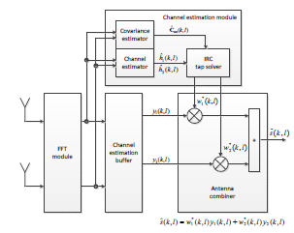



Figure 11‑3 IRC detector performing antenna combining for subcarrier k in Ntx=1, Nrx=2 antenna configuration

## Symbol Level Interference Cancellation (SLIC)

## Successive Interference Cancellation (SIC) Receiver

“SIC” is the algorithm that serially cancels the “interference”. The interference can be: intra-user, e.g. Rank-2 SU-MIMO, inter-user, e.g. MU-MIMO, inter-cell. SIC (and in general IC data receivers) comes in two flavors regarding the cancellation “depth”: Symbol-level (decoding not involved), Bit-level (decoding involved).

The general RS-IC flow could be as follows:

1. Channel estimation is performed for the serving cell.
2. Based on the serving cell channel estimation, DMRS-SIC can be performed for the interfering cell.
3. Then channel estimation can be performed for the interfering cell and based on that, DMRS-SIC can be performed for the serving cell.
4. Channel estimation is performed again for the serving cell but now from the cleaned signal. Consequently the quality of the second channel estimation for the serving cell has been improved.
5. In the case of non-colliding RS, PDSCH REs can be cleaned based on the channel estimates of serving cell and interfering cell. To be more exact, contribution of CRS from interfering eNBs can be subtracted based on CRS channel estimates from those REs where PDSCH and CRS collide

For instance, for the configure-grant study in URLLC there were up to 2 UEs transmitting using same resources (collision case), and the DMRS-SIC flow is as follows: If only one of the two users is detected, channel estimation is performed using the DMRS of the detected user. This channel estimate is used to reconstruct the DMRS of the detected user. This reconstructed DMRS is then subtracted from the overall received signal and detection of the initially undetected user is performed again.

# Antenna array and panel antenna array modelling

|  |  |
| --- | --- |
| Author | Pasi Kinunnen |
| Related functions |  |

## TRXU virtualization

## TRP and UE beamforming

# Link adaptation (LA), Outer Loop Link Adaptation (OLLA)

## Link abstraction algorithm

|  |  |
| --- | --- |
| Author | Panayiotis Papadimitrou |

1. Get the LA **fudge factor λ**, from the **coding rate R** (not counting the **modulation order, m**) of the MCS.
2. Get the **β=[β1 β2] factor**, from the coding rate R (not counting the modulation order, m) of the MCS.
3. Get the post-detection estimated codeword **SINR** over a set of subcarriers.
4. Offset the estimated (post-detection) SINR by OLLA adjustment factor **δ**, and SINR offset **ε**,
5. Offset the SINR_dB by fudge factor λ,

1. Calculate the **Mutual Information MI** of the modulation (QPSK, xQAM) in the SINR_dB points, using modulation **look-up table** and then **interpolating to SINR_dB points**.
2. **Normalize** Mutual Information MI by dividing with the modulation order of the MCS.
3. Average out the result to get the **average Mutual Information MIavg**.
4. Calculate BLER from **Iavg** and **β**,

Note: the tanh function is used to mimic the BLER curve (it’s a sigmoid function).

 

1. Calculate the Throughput (**L** is the number of **layers** 1 or 2),

(**) aproximation of

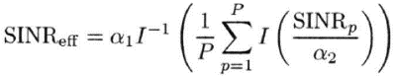

**λ** values in Korak:

|  |
| --- |
| obj.laFudgeFactors.R1_3 = -0.14051; |
| obj.laFudgeFactors.R2_5 = 0; |
| obj.laFudgeFactors.R9_20 = 0; |
| obj.laFudgeFactors.R1_2 = -0.18225; |
| obj.laFudgeFactors.R11_20 = 0; |
| obj.laFudgeFactors.R3_5 = 0; |
| obj.laFudgeFactors.R5_8 = 0; |
| obj.laFudgeFactors.R2_3 = 0.10138; |
| obj.laFudgeFactors.R17_24 = 0; |
| obj.laFudgeFactors.R3_4 = 0; |
| obj.laFudgeFactors.R4_5 = 0.14188; |
| obj.laFudgeFactors.R5_6 = 0; |

**β** values in Korak:

|  |
| --- |
| obj.beta.R1_3 = [106.9389 0.3834]; |
| obj.beta.R2_5 = [101.9549 0.4667]; |
| obj.beta.R9_20 = [111.0378 0.5141]; |
| obj.beta.R1_2 = [96.8091 0.5500]; |
| obj.beta.R11_20 = [88.5879 0.6138]; |
| obj.beta.R3_5 = [88.9059 0.6686]; |
| obj.beta.R5_8 = [98.6135 0.6894]; |
| obj.beta.R2_3 = [101.9146 0.7152]; |
| obj.beta.R17_24 = [90.6997 0.7633]; |
| obj.beta.R3_4 = [83.1487 0.8073]; |
| obj.beta.R4_5 = [90.8751 0.8407]; |
| obj.beta.R5_6 = [85.9978 0.8777]; |

|  |
| --- |
| **case 'QPSK'** |
| modSNR=[-20:25].';  modMutInf=[0.014371 0.018058 0.022901 0.028532 0.035862 0.045228 0.056617 0.070418 0.088545 0.11013...  0.13739 0.17152 0.21193 0.26242 0.32255 0.39343 0.48287 0.58449 0.69817 0.82821 0.97362 1.1257...  1.2817 1.4423 1.5902 1.7178 1.8239 1.9002 1.952 1.981 1.9938 1.9985 1.9996 1.9999 2 2 2 2 2 2 2 2 2 2 2 2]; |
| **case '16QAM'** |
| modSNR=[-20:25].';  modMutInf=[0.011437 0.014391 0.018037 0.02287 0.029152 0.036886 0.044806 0.057101 0.071506 0.090362...  0.11392 0.13749 0.17507 0.21768 0.27376 0.34007 0.42034 0.50745 0.6254 0.74169 0.89355 1.0765...  1.2686 1.4791 1.7013 1.9374 2.1574 2.4309 2.678 2.9044 3.166 3.3927 3.5874 3.7363 3.8547 3.9213...  3.9771 3.9889 3.9989 3.9999 3.9999 4 4 4 4 4]; |
| **case '64QAM'** |
| modSNR= [-20:27].';  modMutInf=[0.011169 0.013863 0.017617 0.02149 0.027614 0.03408 0.042718 0.054516 0.068927 0.084411 0.1077...  0.13491 0.16938 0.20718 0.25784 0.32048 0.39484 0.48277 0.58274 0.7078 0.84633 1.0053 1.1666 1.3671...  1.5672 1.8041 2.0513 2.3164 2.5754 2.8911 3.1861 3.4768 3.7698 4.0887 4.3745 4.6614 4.9492 5.2141...  5.46 5.6545 5.8031 5.8922 5.9565 5.982 5.996 5.9998 6 6]; |
| **case '256QAM'** |
| modSNR=[-20:35].';  modMutInf=[0.014296 0.018112 0.022631 0.028509 0.035944 0.044776 0.056377 0.070226 0.088378 0.1104 0.13754...  0.17127 0.21204 0.26326 0.32221 0.39702 0.48232 0.58527 0.70304 0.83733 0.99448 1.1611 1.3512 1.5519...  1.768 1.9969 2.236 2.4877 2.7443 3.01 3.2833 3.5612 3.8465 4.1373 4.4317 4.729 5.0295 5.3336 5.6394...  5.9476 6.2571 6.565 6.8653 7.1492 7.4046 7.6173 7.7768 7.8867 7.9511 7.9828 7.9954 7.9991 7.9999 8 8 8]; |

As an example of the algorithm implementation, Figure 13‑1 and Figure 13‑2 show BLER and TP from the Korak’s algorithm.



Figure 13‑1 BLER from the Korak’s Algorithm



Figure 13‑2 Throughput from the Algorithm

The previous figures show the BLER and the Throughput (Maximum Rate per Symbol) as were outputted from the Link Abstraction Algorithm. The way it works is the following:

* Given the channel estimates and the receiver type, the **post-detection SINR** is calculated which is mapped to the codeword.
* Given also the **MCS**, the BLER/Throughput are calculated from the Algorithm.
* **The MCS that yields the highest Throughput is selected**.

## NR downlink link adaptation

|  |  |
| --- | --- |
| Author | Mikko Maenpaa, Hesham Elgendi |
| Related functions | NR_DL_LinkAdaptation.m |

Based on [15], the link adaptation is a key feature of any modern mobile communication cellular system. It refers to adapting transmission settings to take advantage of the time and frequency varying channel response. The purpose of LA is to improve system capacity, peak data rates, and coverage. System capacity is improved by more efficient utilization of frequency spectrum, as it is very scarce and expensive resource in wireless communications. Peak data rates are achieved when maximizing the used MCS for UEs in good channel conditions. Coverage can be improved through improved system capacity, and also by accurate IM enabling accurate MCS adaptation for cell edge UEs in time varying interference conditions.

LA is performed at the gNB and decisions about the next transmission settings, e.g. MCS, are based on CQI reports provided by the UE. The CQI frequency granularity and periodicity is configured by the gNB. The frequency granularity of the CQI reports can be Wideband CQI, gNBconfigured sub-band CQI, or UE-selected sub-band CQI. In time domain, CQI reports support periodic, aperiodic, or semi-persistent reporting modes. In this paper, periodic wideband CQI is reported every 5 subframes, corresponding to time interval of 5 ms, where a single wideband CQI index is reported that reflects the average channel condition for the UE specific transmission bandwidth.

### Channel Quality Indicator Definition and Calculation

The performance of the LA is greatly affected by the accuracy of CQI reports, which is strongly dependent on the accuracy of the channel and interference measurements at the UE. The CQI provides a recommendation about the next transmission MCS, so that a certain target block error rate (BLER) can be achieved. An ideal CQI report would thus be the true signal-to-interference-and-noise-ratio (SINR) on a PRB basis as observed by the UE. This would provide a very accurate information on the channel and interference responses to LA, but it is not practical as the SINR estimation always contains some errors and a PRB wise signaling implies a very high uplink overhead.

In general in Korak, wideband CQI is used to reduce uplink overhead and it is calculated as follows. First, desired channel is measured using the scheduled NZP CSI-RS signal. Then the instantaneous interference-plus-noise covariance matrix is measured using either the scheduled CSI-IM or NZP CSIRS resources. Next, the post detection SINR per RE of the received signal is calculated using minimum-mean-squared error interference-rejection-combining (MMSE-IRC) receiver. In this case, mean mutual information per bit (MMIB) is evaluated as presented in [17], and is used as a link quality metric. Post detection RE wise SINRs are mapped to mutual information per bit values using pre-calculated and stored look-up tables, and the average of these values corresponds to MMIB. The obtained MMIB is used to get the MCS that delivers the highest throughput (TP) by searching through all possible MCS indices. For example, starting from the first MCS index, number of transmitted bits and the code block size is calculated as a function of MCS. Then using BLER prediction algorithm defined in [18],the BLER is estimated for this transmission having parameters code block size, MCS, and MMIB as inputs. Estimated BLER is used to calculate TP. This TP is stored and then compared to the obtained TP of the next MCS index until the highest possible TP and corresponding MCS is found. Then the obtained MCS is mapped to the closest CQI index in CQI table in TS 38214. Finally, BLER is estimated for the selected CQI to ensure that the target BLER is achieved. If the estimated BLER is larger than the target BLER, the selected CQI index is reduced by one

### Outer Loop Link Adaptation (OLLA)

The OLLA is a scheme that aims to correct inaccuracies of CQI calculations so that a certain target BLER of the first hybrid automatic repeat request (HARQ) transmission can be achieved. There are different sources for these inaccuracies, e.g., estimation errors in channel and interference measurements performed by UE, and in practice there is always a delay between CQI calculations and when it is available at the gNB. OLLA is performed by the gNB and different schemes are proposed in the literature to cope with inaccuracies of CQI calculations.

### Generic parameterization

Major functionalities:

- CQI calculation

- PMI calculation

- Channel and interference measurement filtering

- MMIB-to-BLER mapping for NR

|  |  |  |  |
| --- | --- | --- | --- |
| **Model Parameter** | **Description** | **Value** | **Default value** |
| method | Link adaptation method | string | LTE-legacy  | NR-DL-MMIB-to-BLER-mapping |
| BLER-target |  | integer | 0.1 |
| save-statistics |  |  |  |
| MMIB-to-BLER-look-up-table-selection  use |  |  | auto-select-based-on-LDPC-configuration |  LDPC-min-sum-15-iterations |  LDPC-accurate-50-iterations |
| **CQI related** | | | |
| CQI-table-selection | See (Note 1) for CQI indices | string | upTo64QAM | upTo256QAM |  64QAMlowSE |
| mode | In case of subband-CQI, the subband-size should be defined. |  | wideband-CQI | subband-CQI |
| **PMI related** | | | |
| use-physical-channel-precoding-configuration |  | string | yes | no |
| **CSI acquisition related** (Note 2) | | | |
| antenna-pattern-induced-SNR-offset-dB |  | integer | 0 |
| channel-measurement  use | For NZP CSI-RS based channel estimation, also release and ID has to be defined | string | ideal-channel-estimation |  csi-rs-channel-estimation |
| channel-measurement  forgetting-factor |  | integer | 0 dB |
| interference-measurement  use |  |  | ideal-IoNo | estimated-IoNo-nr-pdsch-dmrs |  estimated-covariance-nr-pdsch-dmrs | csi-im-cov-estimation | csi-im-diag-cov-estimation | csi-im-iono-estimation | estimated-covariance-nr-nzp-csirs | estimated-IoNo-nr-nzp-csirs |
| interference-measurement  forgetting-factor |  | integer | 0 dB |
| **CSI reporting related** | | | |
| csi-feedback-delay-in-subframes |  | integer | 0 |
| fixed-feedback-periodicity  || use-csi-rs-configuration | See (Note 3) for periodicitydefinition |  |  |

(Note 1) The CQI indices and their interpretations are given in Table 5.2.2.1-2 ('upTo64QAM') or Table 5.2.2.1-4 ('64QAMlowSE') of TS 38214-g00 for reporting CQI based on QPSK, 16QAM and 64QAM. The CQI indices and their interpretations are given in Table 5.2.2.1-3 ('upTo256QAM') for reporting CQI based on QPSK, 16QAM, 64QAM and 256QAM.

MCS tables: Table 5.1.3.1-1 ('upTo64QAM'), Table 5.1.3.1-2 ('64QAMlowSE') and Table 5.1.3.1-3 ('upTo256QAM') of TS 38214-g00

(Note 2) You need to define channel and/or interference measurement method in XML.

(Note 3)

**1.** In case *fixed-feedback-periodicity* is defined, *report-every-n-th-subframe* should be defined

**2.**  In case *use-csi-rs-configuration* is defined, configuration is taken from NZP-CSI-RS-r15

|  |  |  |  |
| --- | --- | --- | --- |
| **Model Parameter** | **Description** | **Value** | **Default value** |
| active |  |  |  |
| target-bler |  |  |  |
| delta-CQI-step-up |  |  |  |
| delta-CQI-max |  |  |  |
| delta-CQI-min |  |  |  |
| delta-CQI-initial |  |  |  |

# Link to system (L2S) Mapping Interface

## L2S mapping for SLIC Receiver (check)

|  |  |
| --- | --- |
| Author | Jie Zang, Toni Huovinen |

This section provides the Link-to-System (L2S) package for Network Assistant Interference Cancellation and Suppression (NAICS) Symbol Level Interference Cancellation (SLIC) receiver. The flow diagram of the whole L2S process is shown in **Error! Reference source not found.**. First, the link level simulation is done under certain assumptions. The extracted data from link simulation is then used in Interference Cancellation (IC) efficiency and BLER prediction. The IC efficiency and predicted BLER parameters will be implemented in system level simulator for further investigation. At this point, we discuss about the link level simulation and present only so called IC efficiency table approach. Moreover, SLIC L2S model is currently limited to one cancelled rank-1 interferer only.

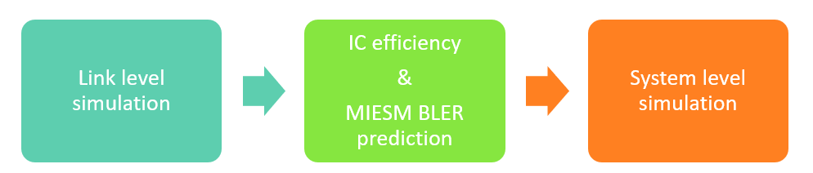

Figure 14‑1 L2S process

In the following sections, the theoretical background for L2S mapping is introduced and we provide the detailed information about link level simulation and steps to obtain the L2S table.

### Mutual information effective SINR mapping

#### Theoretical background

The model was first adopted from Sec.9.1.3 in 3GPP TR 36.866(V1.0.0). To model code word Block Error Rate (BLER) performance for SLIC receiver, the general approach is to derive the mutual information per transmitted bit (MIB) on each Resource Element (RE) of the Physical Downlink Shared Channel (PDSCH). Since system level simulator does not have RE level modelling MIB derived for smallest time-frequency (TF) unit available (the smallest unit is configurable but typically it is one Physical Resource Block (PRB)), the MIB values are averaged over all TF unit before mapping average MIB to a BLER. MIB value of SLIC receiver at one TF unit is based on weighting between the MIBs at a lower-bound and an upper-bound SINR which is described as:

|  |  |  |
| --- | --- | --- |
|  |  |  |

where the function *f* maps on Signal to Interference plus Noise (SINR) value to the corresponding MIB; weight γ is IC efficiency parameters; *SINRL* and *SINRU* are lower and upper bound SINRs. The lower bound SINR is post-processing SINR of Linear Minimum Mean Square Error (LMMSE) or Interference Rejection Combing (IRC) receiver without any nonlinear processing. The upper bound SINR is post processing SINR of LMMSE or IRC receiver after perfect dominant interference(s) cancellation.

Weight γ defines the IC efficiency, which has properties as follows:

* Small positive values (close to zero) corresponds to poor cancellation performance;
* High values (close to one) corresponds to good cancellation performance;
* Negative values would correspond to performance loss compare to IRC. However, with soft interference detectors negative values should not appear;
* Variable depending on SINR experienced by interference detection (DISINR), serving modulation and interference modulation of time-frequency unit at hand.
* In practice, system level simulator reads γ from predetermined, serving modulation and interference modulation dependent L2S lookup table after calculating DISINR.

From previous equation solving γ gives

|  |  |
| --- | --- |
|  |  |

On the right hand side of the expression above, elements except *MIBSLIC* can be formed based on effective channel responses (input from link-level L2S data extraction). The *MIBSLIC* term can be expressed as

|  |  |  |
| --- | --- | --- |
|  |  |  |

where the SINR samples need to be obtained from Monte-Carlo simulations. The derivation ofthough Monte-Carlo process is discussed later.

#### Monte-Carlo simulations

The received signal can be modelled as:

|  |  |  |
| --- | --- | --- |
|  |  |  |

where and are transmitted signals, and are the effective channels and is noise vector.

Linear receiver for interferer can be modelled as:

|  |  |  |
| --- | --- | --- |
|  |  |  |

where  is the inverse of estimated covariance of received signal,and are estimated channel response, the superscript *H* denotes the complex conjugate transpose,is estimated covariance of other noise. The decision statistic for interfere is then

|  |  |  |
| --- | --- | --- |
|  |  |  |

where is the estimated interference symbol. The interference canceller writes as

|  |  |  |
| --- | --- | --- |
|  |  |  |

and linear receiver for victim as

|  |  |  |
| --- | --- | --- |
|  | . |  |

Using these we get decision statistic for victim:

|  |  |  |
| --- | --- | --- |
|  | . |  |

Finally, the post-processing SINR of SLIC receiver can be expressed as

|  |  |  |
| --- | --- | --- |
|  |  |  |

where ***C****residual* is covariance of residual interference .

The post-processing DISINR can be expressed as

|  |  |  |
| --- | --- | --- |
|  |  |  |

where  embeds other interference stream contribution.

In SINRSLIC equation, we can form all the terms directly except for ***C****residual*, which needs to be obtained by Monte-Carol simulations. In the Monte-Carlo process, we first generate a number of modulated samples as transmitted symbols and . The received symbols are then formed with transmitted symbols, effective channels and noise (effective channels and noise power are extracted from L2S link simulation). The estimated symbols  are soft-detected from  (equation above) with the help from linear receiver equalizer for interferer. The covariance of residual interference term is calculated as

|  |  |  |
| --- | --- | --- |
|  |  | (2.12) |

where *L* is number of generated samples.

#### IC efficiency fitting

The IC efficiency ** can be evaluated either in SINR domain or mutual information (MI) domain. We found out that MI domain evaluation leads to better fitting result. Figure 14‑2 shows example of simulated IC efficiency samples vs. DISINR. In the figure, IC efficiency was calculated for each serving-interfering channel realization pair after evaluating *SINRSLIC* with Monte-Carlo simulation explained in previous section. In addition, DISINR was calculated.

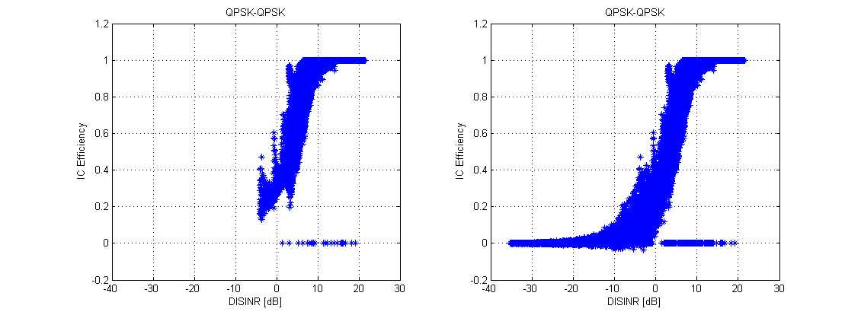

Figure 14‑2 Example of simulated IC efficiency samples vs. DISINR

One single IC efficiency curve is needed to represent all ** for one serving-interference cell modulation combination. This single IC efficiency curve can be found by fitting the data samples with sigmoid function. Based on the observation, five parameter asymmetry sigmoid function is used in the fitting:

|  |  |  |
| --- | --- | --- |
|  |  |  |

where *d* is maximum asymptote, *c* is minimum asymptote, *b* is slope, *a* is inflection point, *f* is asymmetry parameter. An illustration figure is shown Figure 14‑3.



Figure 14‑3 illustration of five parameter sigmoid function

In current L2S campaign, IC efficiency is between 0 and 1. Therefore, the Eq. can be further reduced to

|  |  |  |
| --- | --- | --- |
|  |  |  |
|  |  |  |

An example of IC efficiency fitting is shown in Figure 14‑4 where the blue dots are the simulated IC efficiency data samples for QPSK-QPSK serving-interference modulation combination and red line is the fitting line to the observed data.

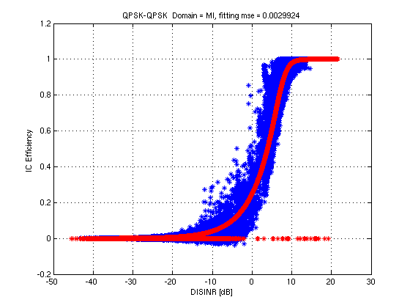

Figure 14‑4 Example of IC efficiency fitting with QPSK-QPSK serving-interference modulation

#### MIESM BLER predictor for SLIC

The overall process for SLIC BLER prediction in case of one rank-1 dominant interference is

1. Calculate upper bound *SINRU* and lower bound *SINRL*, for each sub-frequency of transport block. (Only *SINRL* is needed for sub-frequencies where DI does not have transmission or have rank2 transmission)
2. Calculate SLIC MIBs using IC efficiency mapping for each sub-frequency:

|  |
| --- |
|  |

1. Covert SLIC MIBs to SINR domain and store them as linear values in vector **s**

|  |  |  |
| --- | --- | --- |
|  |  |  |

1. Calculate effective SINR using the old (MI)ESM mapping:

|  |  |  |
| --- | --- | --- |
|  |  |  |

1. Map the effective SINR to BLER



## Modeling approach in NR

|  |  |
| --- | --- |
| Author | Mikko Maenpaa, Hesham Elgendi |

Link to system (L2S) look-up table are created based on LDPC coded NR-PDSCH. Main requirements are as follows:

* Support of an arbitrary Code Rate (CR), Transport Block Size (TBS) and Modulation combinations.
* Support of spatial multiplexing schemes with a single CW transmitted over multiple layers.
* Allowing combination of HARQ blocks using different MCSs and TBSs.
* Support of two different LDPC configurations
  + For upper bound performance: 50 iterations with accurate LDPC decoding
  + For more practical performance: 15 iterations with min-sum LDPC decoding

Post-processing/receiver SINRs for each subcarrier of each slot and layer come to the input of L2S mapping interface. The obtained SINR values are used for MIB calculation taking the modulation into account. Then, MMIB value for the transport block is calculated. Finally, the BLER estimate is calculated taking CR and TBS values for the transmitted TB into account. The modeling approach is based on [19, 20].

From post-detection SINR per RE to BLER estimate. The modeling approach SINR-to-MMIB-to-BLER is shown in Figure 14‑51.

1The figure is initially copied and modified from the figure in document “PHY abstraction methods for 5G, Krzysztof Bakowski, Nokia”.

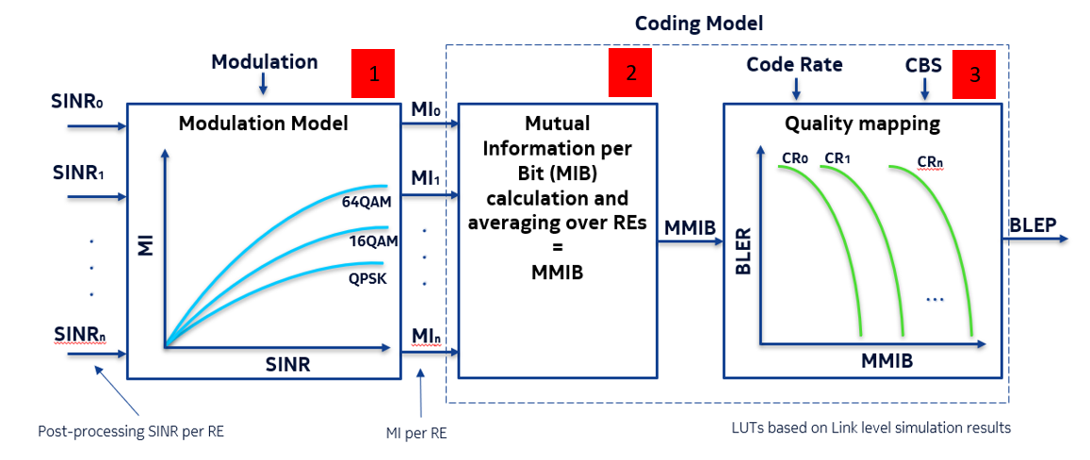

Figure 14‑5 Modeling approach

The simulation assumptions for the BLER vs. MMIB reference curves are as follows:

* General: SISO, AWGN, Ideal channel estimation, No Tx impairements
* Channel coding: LDPC (50 iterations, decoder type = "accurate/3")
  + Support also for LDPC with 15 iterations and min-sum decoder type
* Code-block-sizes: 40 (minimum), 136, 496, 1752, 3840, 8448 (maximum).
  + Number of data bits: 24 ,120, 480, 1736, 3824, 8424
  + Block size for LDPC: 70, 240, 640, 1760, 3840, 8448
* Coding rates per CBS: 0.1, 0.15, 0.25, 0.35, 0.5, 0.65, 0.75, 0.83, 0.88, 0.93.

Based on these assumptions, the MIB vs. SINR dependences for different types of modulation are shown in Figure 14‑6 (stage 1 in Figure 14‑5).



Figure 14‑6 MIB vs. SINR

and the full set of reference BLER vs. MMIB curves are shown in Figure 14‑7 (stage 3 in Figure 14‑5). In this case, the curve color designate CR with the following values left to right: 0.1. 0.15, 0.25, 0.35, 0.5, 0.65, 0.75, 0.83, 0.88 and 0.93. Markers designate CBS with the following values by increase of curve slope (right to left): 40, 136, 496, 1752, 3840 and 8848.



Figure 14‑7 BLER vs. MMIB

These reference curves are used to create look-up-tables

### Calculation of BLER

For an arbitrary input MMIB and arbitrary CR and TBS/CBS:

* As may be seen from the reference BLER vs. MMIB curves in Figure 14‑8, for equal CR values, curves for different CBS values differ in slope. Therefore, the presented two-parameter set of curves cannot be reduced to a one-parameter set keeping the same BLER prediction accuracy for low CBS values. Thus, the developed MMIB-to-BLER mapping interface operates using the two-parameter curve set shown in Figure 14‑8.
* The BLER for an arbitrary input MMIB and arbitrary CR and CBS can be calculated by means of interpolation between the reference curves. Illustration of the interpolation process is shown in next section.

### Interpolation process between the reference curves

Supported CBSs in LUTs: 40, ***136, 496***, 1752, 3840, 8448.

Supported CRs in LUTs: 0.1, 0.15, 0.25, ***0.35, 0.5*,** 0.65, 0.75, 0.83, 0.88, 0.93.

**Inputs: CBS = 316, CR = 0.4, MMIB = 0.5**

* Step 1 : Selecting two CBS and CR values closest to the input CBS and CR, respectively.



Figure 14‑8 Step 1 of the interpolation process

* Step 2: Linear interpolation by the CR parameter for each CBS value.
* Step 3: Linear interpolation by CBS parameter in logarithmic scale.
  + The calculated curve (see green dashed curve) is the BLER vs. MMIB characteristic for the input CR and CBS parameters.



Figure 14‑9 Steps 2 and 3 of the interpolation process

* Step 4: Calculate the output BLER as a function of input MMIB value.
  + Two points interpolation for input MMIB between the two closest MMIB values in the generated BLER vs. MMIB characteristic (green curve).
* Step 5 (optional): If the input MMIB value is less or higher than values in the generated BLER vs. MMIB curve, extrapolation can be used, or simply assuming BLER is one or zero.

### Calculation of BLER in case of code block segmentation

If the size of a transmitted TB exceeds the maximum available code block size(**), the transmission of such a TB is performed using code block segmentation (splitting of a whole TB into several code blocks).

Independent decoding of the segmented blocks allows calculating the probability of an error for the whole TB from the set of probabilities of error for separate segments by the following formula:

,

where is the BLER for *r*-th segment, *r* is the segment index [19, 20].

(**)In NR Release 15, the maximum code block size is defined as follows:

A = number of data bits

if (A < 292 || (A <= 3824 && codeRate <= 2/3) || codeRate <= ¼)

CBS_max = 3840;

else

CBS_max = 8448;

end

# Fine Tracking Modelling

|  |  |
| --- | --- |
| Author | Panayiotis Papadimitriou, Andrei Malkov and Heikki Berg |
| Related functions | TimeOffModel.m |

The main algorithm is a time-domain correlator with maximum search for both timing and frequency tracking.

## Time Offset Modelling

### Model A

This model generates a simple time offset, in other words, like in “real-life”. The logic is as follows:

1. Set the timing offset range to [-τ,τ]. Initialize estimated timing offset to 0.
2. Introduce an initial timing offset (within the above range, it can be 0) once every S subframes (for instance S = inf)
3. Shift the signal according to timing offset = timing offset - estimated timing offset
4. Estimate the timing offset (search for peak on the above timing offset range)
5. Log the error between the estimated timing offset and the target timing offset (0 for simplicity)
6. Continue to step 3, and repeat until all subframes are received

*Estimated timing offset based on exact algorithm: refer to DMRS, generic one

### Model B

This model generates a random time offset. The logic is as follows:

1. Set the timing offset range to [-τ,τ]
2. Introduce a new uniformly distributed (within the above range) random timing offset every subframe
3. Shift the signal with the timing offset of step 2
4. Estimate the timing offset
5. Log the error between the actual and the estimated timing offset
6. Continue to step 2, and repeat until all subframes are received

*Estimated timing offset based on exact algorithm: refer to DMRS, generic one

## Frequency Offset Modelling

### Model B

This model generates a random time offset. The logic is as follows:

1. Set the frequency offset range to [-f,f]
2. Introduce a new uniformly distributed (within the above range) random frequency offset every 5 subframes, starting from subframe mod(subframe#, 5)==1 (subframes# in [0,9]).
3. Frequency offset the transmitted signal
4. Estimate the frequency offset
5. Log the error between the actual and the estimated frequency offset
6. Continue to step 2, and repeat until all subframes are received

*Estimated frequency offset based on exact algorithm: ?

# Others

## Tx Error Vector Magnitude (EVM)

## High Speed Train (HST) scenario modelling

## Power amplifier (PA) models

# References

|  |  |
| --- | --- |
| [1] | ”3GPP TR 38211 V16.0.0, "Physical channels and modulation", Tech. Spec. Group Radio Access Network, Rel. 16”. |
| [2] | ”3GPP TR 38212 V16.0.0, "Multiplexing and Channel Coding", Tech. Spec. Group Radio Access Network, Rel. 16”. |
| [3] | ”3GPP TR 38213 V16.0.0, "Physical layer procedures control", Tech. Spec. Group Radio Access Network, Rel. 16”. |
| [4] | ”3GPP TS 38.214 v16.0.0, "NR, Physical layers procedures for data",Tech. Spec. Group Radio Access Network, Rel. 16”. |
| [5] | M. Maenpaa, ”Blind Detection of Interfering Cell Data Channel Power Level in 3GPP LTE / LTE - Advanced Downlink Power Level in 3GPP LTE / LTE - Advanced Downlink,” May 2016. |
| [6] | ”https://confluence.int.net.nokia.com/pages/viewpage.action?spaceKey=korak&title=Korak+-+Physical+Layer+Simulator”. |
| [7] | I. T. a. M. B. Stefania Sesia, ”LTE - From Theory to Practice.,” tekijä: *John Wiley & Sons, Inc.*, 2009. |
| [8] | F. Laue, P. Karunakaran ja R. Schober, ”Detection Schemes and Model Mismatch Analysis for 5G Configured-Grant Access for URLLC,” tekijä: *IEEE Globecom Workshops (GC Wkshps) (pp. 1-6). IEEE.*, 2019. |
| [9] | E. Peralta, M. Mäenpää, T. Levanen, Y. Yuk, K. Pedersen, S. Nielsen ja M. Valkama, ”Reference Signal Design for Remote Interference Management in 5G New Radio.,” tekijä: *2019 European Conference on Networks and Communications (EuCNC), IEEE*, 2019, June. |
| [10] | E. Peralta, M. Mäenpää, T. Levanen, Y. Yuk, K. Pedersen, S. Nielsen ja M. Valkama, ”Remote Interference Management in 5G New Radio: Methods and Performance,” tekijä: *Special Issue on "Enabling Technologies for Networks beyond 5G" of the EURASIP Journal of Wireless Communications and Networking*, 2020. |
| [11] | W. Jakes, ”Microwave Mobile Communications 2nd.ed. ISBN 978-0780310698”. |
| [12] | F. Kschischang, B. Frey ja H. Loeliger, ”Factor graphs and the sum-product algorithm.,” tekijä: *IEEE Trans. Information Theory*, 2001. |
| [13] | J. Z. F. &. B. A. H. Zhao, ”On implementation of min-sum algorithm and its modifications for decoding low-density parity-check (LDPC) codes,” 2005. |
| [14] | Y.-h. Jian, ”Presentation on theme: Team LDPC,” tekijä: *SoC Lab. CS Dept. National Taiwan University Codes and Decoding on General Graphs* . |
| [15] | H. Elgendi, M. Mäenpää, T. Levanen, T. Ihalainen, S. Nielsen ja M. Valkama, ”Interference Measurement Methods in 5G NR: Principles and Performance,” tekijä: *16th International Symposium on Wireless Communication Systems (ISWCS)*, 2019, August. |
| [16] | P. Papadimitriou, T. Ihalainen, H. Berg ja K. Hugl, ”Link-level performance of an LTE UE receiver in synchronous and asynchronous networks,” tekijä: *IEEE Wireless Communications and Networking Conference (WCNC) (pp. 3861-3866). IEEE*, 2013. |
| [17] | L. T. T. e. al., ”Intermediate version of the system level simulator,” tekijä: *Citeseer, CODIV D2.5*, 2007-2013. |
| [18] | V. Shumilov, A. Trushanin ja R. Maslennikov, ” Design of Link-toSystem Mapping Interface for LTE-A Uplink System Level Simulations,” tekijä: *7th ACM Workshiop on Performance Monitoring and Measuring of Heterogeneous Wireless and Wired Networks*, 2012. |
| [19] | V. Shumilov, A. Trushanin, R. Maslennikov, A. Khoryaev ja A. Chervyakov, ”Design of Link-to-System Mapping Interface for LTE-A,” 2012. |
| [20] | J. G. P. a. D. G. Manolakis, ”Digital Signal Processing - Principles, Algorithms, and Applications.,” tekijä: *Prentice-Hall, Inc., Upper Saddle River, NJ,*, 1996. |
| [21] | T. P. Krauss, ”Topics in Signal Processing for Multi-user, Multi-channel Digital Communications.,” tekijä: *PhD thesis, Purdue University*, 2000. |